Fulfilling IEP/ETR Record Requests
Below are directions on how to view/download a student’s most recent ETR and IEP in Infinite Campus to fulfill record requests.
- Search for the student under the current school year and their current school.
- Once you find the student then click INDEX > STUDENT INFORMATION > SPECIAL ED. Find and click IEP (most recent) and/or ETR (most recent).
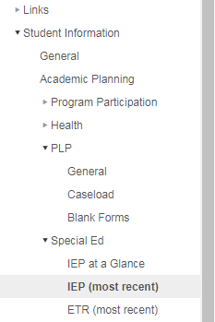
- A new window will appear for the IEP or ETR (see examples below). You can either print or download the document.
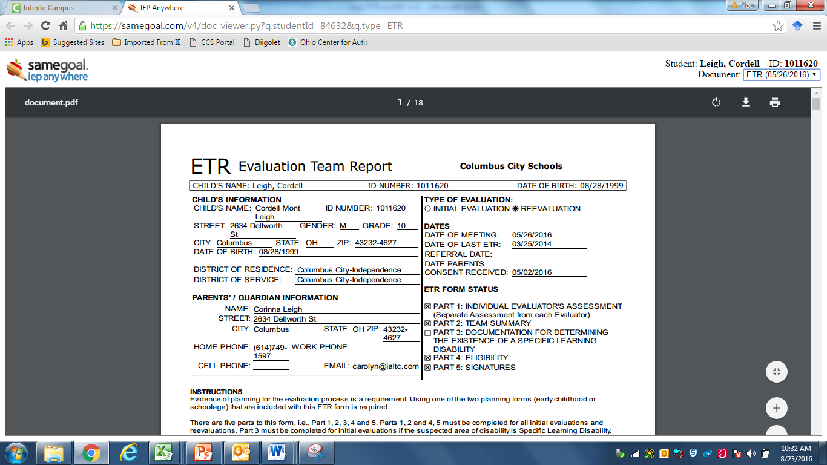
Print or Download
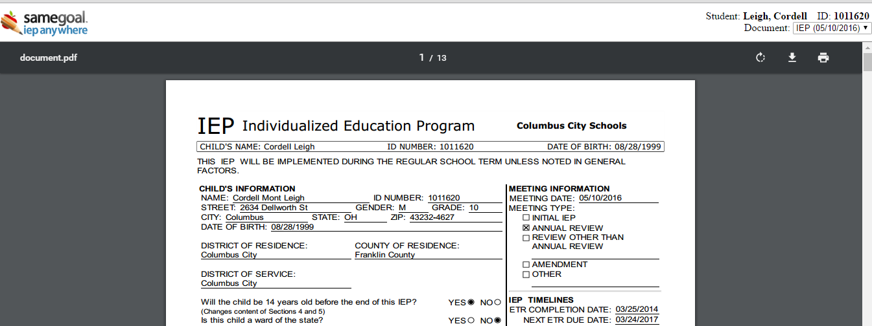
Print or Download

- Schools will need the signature pages for the ETR and IEP. To obtain the signatures pages go to the top right hand corner and click the drop down option next to DOCUMENT. At the bottom of the drop down will be a document to choose. The title of the document could be FULL ETR, ETR SIGNATURES, FULL IEP, or IEP SIGNATURE. School districts are required to have signature pages, therefore it is important to send the IEP AND the signature pages.
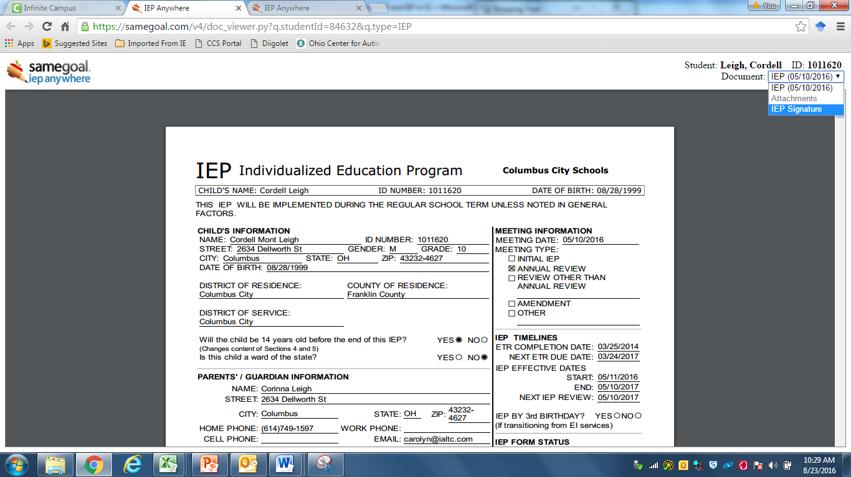

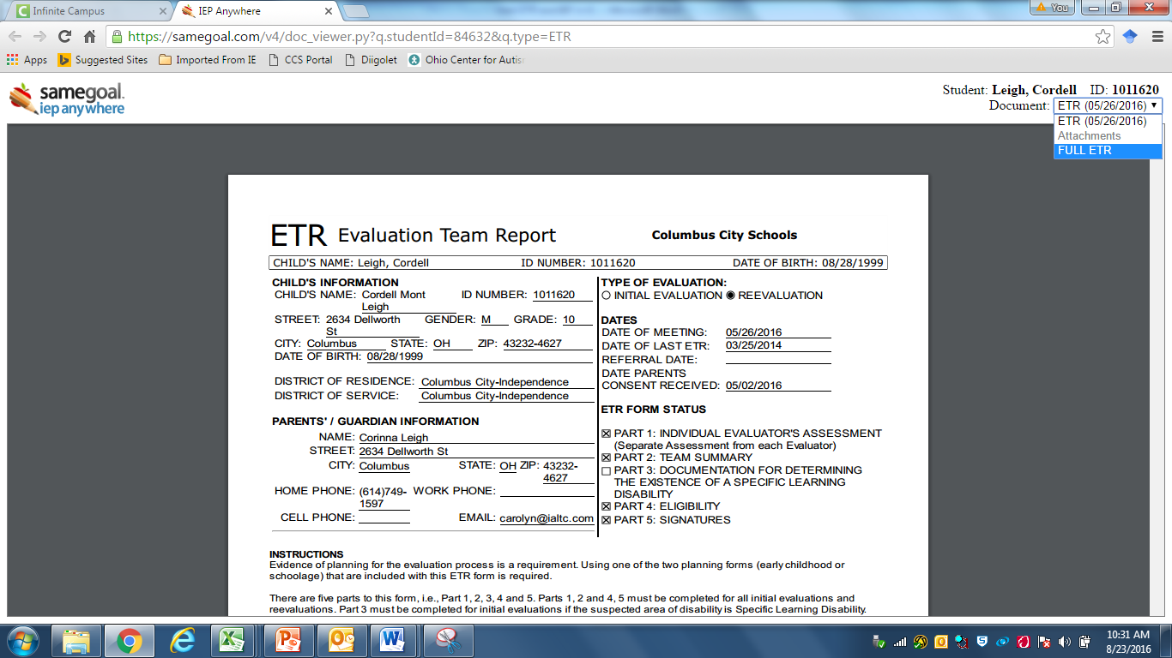
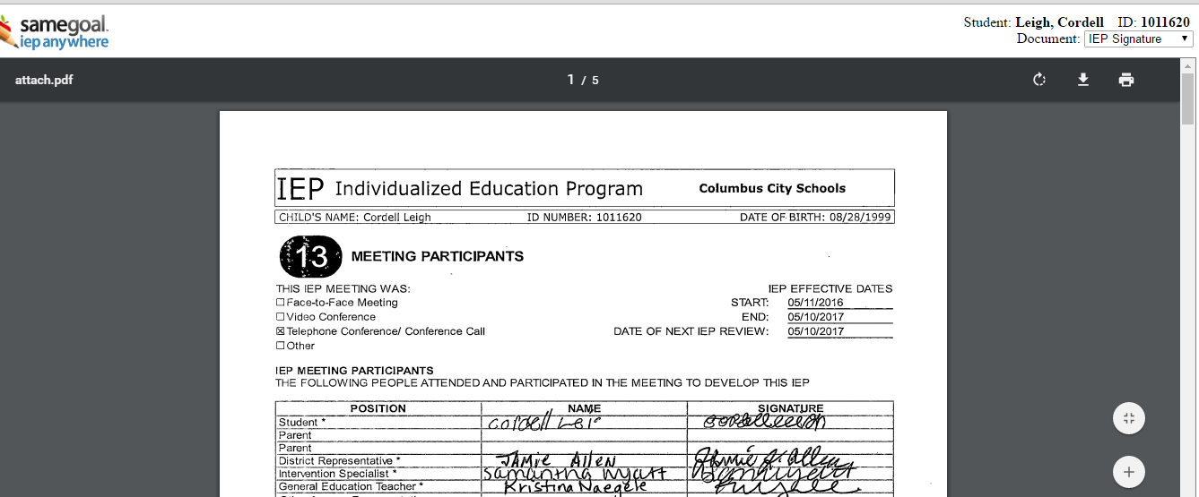
- IEPs often just have the signature pages scanned in therefore it is recommended that you download and send both the first IEP document that first appears and the drop down document titled IEP signatures. ETRs often have the full document scanned, so you may just have to download and send the “Full ETR” after you click the drop down option, but make sure it has a signature before sending it to the other district.
If the IEP/ETR that is downloaded from Infinite Campus does not have the signatures, you MUST pull the paper documents with the signatures and scan them into Scribbles to fulfill the Record Request.

