Infinite Campus End-of-Year
Closeout Meeting – High Schools
Wednesday, May 10, 2017
Kingswood Data Center
Room 56

"Each student is highly educated, prepared for leadership and service, and empowered for success as a citizen in a global community.”

Cathy Kurre, Anne Dale and Cheryl Sturms have recently joined the Student Data Specialists team.

Cathy has been with Columbus City Schools for 18 years. She was a secretary with the Budget Department, Non-Public School Services, for 10 years assisting principals and tutors with budgets, purchase orders, and invoices. She is a former school secretary at Ridgeview Middle School.

Anne

Cheryl has been with Columbus City Schools for 19 years. She spent her first 11 years with the district at North Linden Elementary School. She then moved to payroll where she has spent the last 8 years paying classified staff members and processing retirements.

YEAR END OVERVIEW:

ENROLLMENTS
The Enrollment Roll Forward process automatically ends the 16/17 enrollment and moves students up one grade level for the 17/18 school year with a 7/1/17 start date. It also moves students from elementary (5th) to middle school (6th), middle (8th) to high school (9th), and seniors with a diploma date to graduated status.

Enrollments have begun for the 17/18 school year, these are visible on the student’s enrollment tab. Please note there are various scenarios in which a 17/18 enrollment will exist after a student has been withdrawn. These enrollments will fall off the enrollment tab through an automatic process completed at Kingswood. This process is scheduled various dates from now through the summer. There is no need to submit a help desk ticket or withdraw request to correct these enrollments (we are aware they exist). During the transition to 17/18 notifications will be posted through the Infinite Campus Notification system on the log in screen. You may notice lag time during the transition but the system will not be shut down.

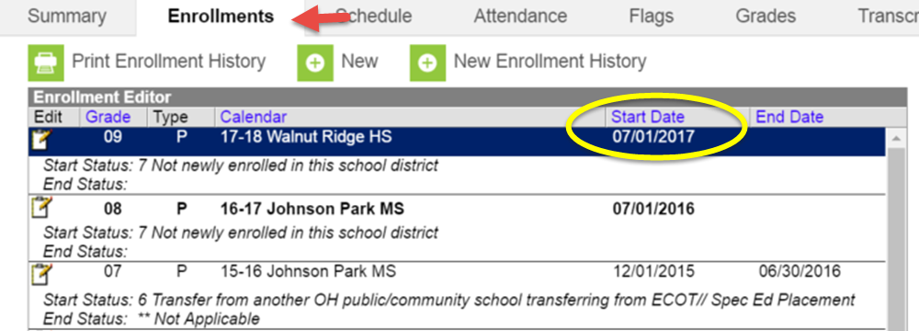

RETENTIONS
All retentions must be submitted through the CCSDAS. Your Administrator and/or Counselor can provide you with the list. Student retention documentation must be uploaded the student’s document tab.

Your Administrator may request for you generate the Retention Report from Infinite Campus. Note: this report will only generate after Central Enrollment has processed your retention requests submitted through CCSDAS. You can locate this report through the following path:

Index>Grading & Standards>Reports>Retentions

For more information regarding the retention process please see the Retention Manual provided by Central Enrollment.

Grade Level Change vs. Retention
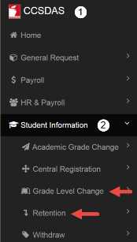
If the 17/18 grade level displays inaccurately after July 1, 2017, process a Grade Level Change through the CCSDAS.
TIP: Retentions added through CCSDAS before DATE can be done in batch. Retentions done after DATE will need to be submitted individually through the CCSDAS Grade Level Change request process.
To retain student for next year, follow the process for retentions that will be distributed in a separate document.

Please see the memo on the following page from the Division of School Choice with important information regarding retention of lottery placed students.

NEED TONYA RETENTION LETTER FOR LOTTERY; still relevant; do we place in retention manual vs. letter?

WITHDRAWALS
Continue to process withdrawals through the CCSDAS for active students moving to another educational entity.

Generate the Withdraw Code Verification Report to identify withdrawals for the 16/17 school year.
- Index > Student Information > Reports > Data Verification Reports > Withdraw Code Verification
- Review end status and codes for accuracy
- Submit the correction through the CCSDAS

The withdraw end status on a student’s enrollment tab must be in alignment with the most recent documentation on file. If at any time new documentation is presented relative to the students withdraw, we must update the withdraw end status code.

For example; A student was withdrawn to code 74: Moved not known to be continuing, and an Unable To Locate (UTL) is on file. Weeks later you receive a records request from Whitehall City Schools indicating student has been actively attending their district since the first day of school. In this example the student should have been withdrawn to end status 41. See steps below for instructions on how to correct a withdraw.

Correcting Withdrawals
If a student is withdrawn to a drop-out reason or is found to be enrolled into a school other than the one the student was withdrawn to, it is important to update the withdraw code as soon as possible.
Drop-Out Withdrawal Codes:
71 – Withdrew Due to Truancy/Nonattendance
72 – Pursued Employment/Work Permit
73 – Over 18 Years of Age
74 – Moved, Unable to locate
75 – Student Completed Course Requirements
79 – No Longer Eligible to be Enrolled in District
The CCSDAS will not allow you to create a new form when correcting a withdrawal. Re-submit a modification to the original form.
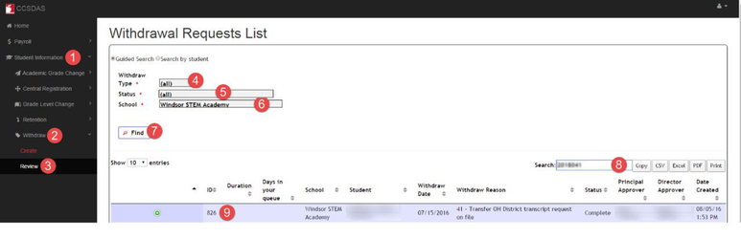
- Once logged into CCSDAS, click on Student Information.
- Click Withdraw.
- Click Review.
- Type: Click in the field and select All.
- Status: Select All.
- School: Select the applicable school.
- Click Find.
- It is optional to enter the student number in the Search field.
- The student will display in the Search results. Click the ID number to open the form.
Correct the Withdraw Reason and Withdraw to IRN as applicable.
Upload supporting documentation as applicable. Requestor Comments can be added as needed. Click the Submit button at the bottom of the page.
Summer Withdraws

Withdraw request must be submitted by the school with the active enrollment.
If you receive a request for records on a student who has transitioned to a new CCS building (Elementary > Middle; Middle > High) you must forward the request to the 17/18 school of enrollment. The most effective way to handle this is to scan and email the request to the new secretary.

Notice: The summer withdraw end date for 17/18 is July 1, 2017.

INSERT NEW SUMMER FLOW CHART AS LINK TO ICD
ATTENDANCE
All attendance data for 2016-2017 must be entered in to Infinite Campus prior to generating report cards. Once all data is entered you will generate the Attendance Summary Report to be included with the students report card. A copy must be placed in the student’s cumulative folder. Use the following path to generate the report:
Index>Attendance>Reports>Attendance Summary
Attendance files should be properly stored using the guide below.
Storing of attendance records:
- Use Staples box #: 895147; MFG #: PGC450 with Avery label: Staples #: AVE8126
- Student attendance documentation must be filed alphabetically and remain in their individually labeled folder. Attendance documentation received after storage must be placed in the appropriate folder.
- Daily attendance folders must be filed chronologically by date and remain their individual folders. The folders must contain the following documents:
  - Early Leave/Late Arrival logs
  - Paper Rosters (field trips, sub attendance)
  - Caller Reports
  - Late Bus Rosters used to class excuse attendance
All attendance files stay at the school building where the attendance occurred and must not be transferred with cumulative folders when a student moves.

BEHAVIOR
All behavior events must be entered in to Infinite Campus prior to generating report cards. All due process discipline letters (Removal, Out of School Suspension, and Expulsion) must be generated, signed by the Administrator and uploaded to the student’s document tab. These removal letters do not get filed in the cumulative folder. Generating the Behavior Resolution Report help identify students who should have a due process letter uploaded. Use the following path to generate the report:
Index>Behavior>Reports>Resolution
For information on how to maintain behavior records refer to the document retention schedule located on the CCS Intranet.

ACADEMIC GRADES
Traditional elementary schools, middle and high schools must have student grades in Campus by June 2, 2016. Woodcrest Elementary School must have student grades in Campus by June 8, 2016. Keep a copy of the report card in the cum folder.

RECORDS

Run School Year End – Leaving report by following this path:
Index > Student Information > Reports > School Year End – Leaving

CENSUS
Editing Student Address
If changing a student’s address, keep in mind:
- It will change the address for ALL students in the household.
- Required documentation is to be provided by the parent/guardian before making a change.
- Follow the instructions carefully. The TLC documentation is available on the TLC SharePoint site.
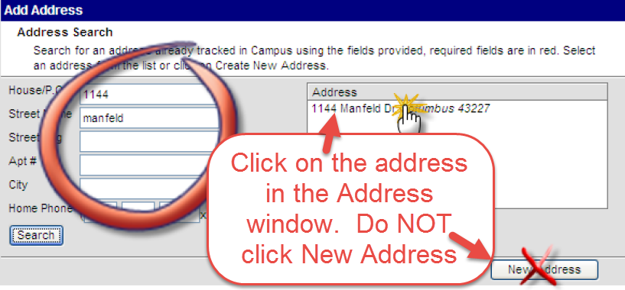
- If you receive a security warning that you do not have access, that means you have clicked on the ‘New Address’ button instead of the address in the Address window.
Address not found in Infinite Campus
If updating a student’s household address in Infinite Campus and the address cannot be found, the address needs to be added to Campus. To request that an address be added, use the Data Request Form on the CCSNet under Quick Links. The form will look like the screen shot below:
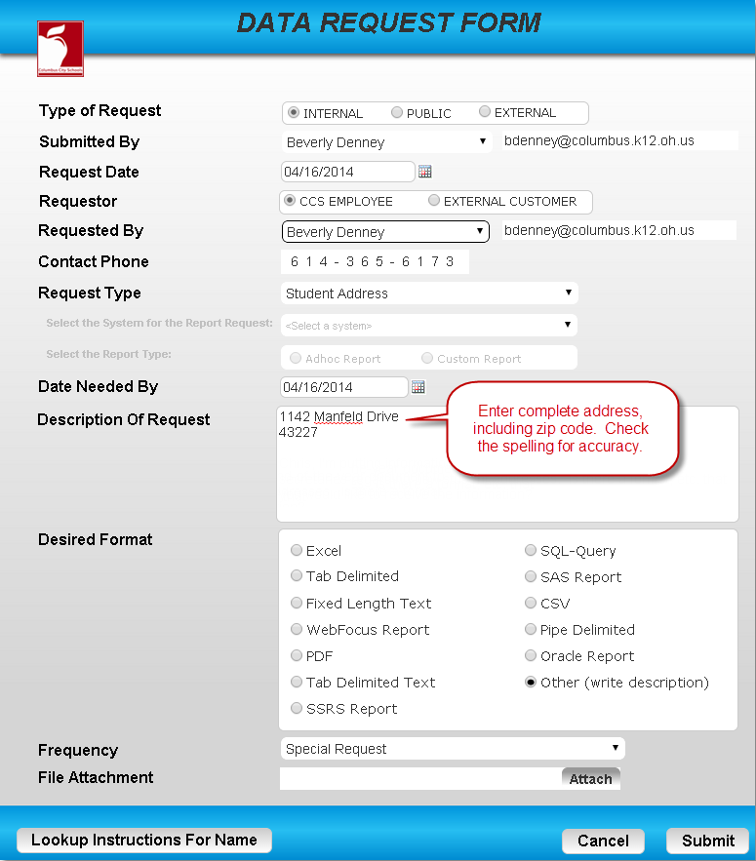
Please be sure to give the complete street address and name. It is very important to include the zip code. Check the spelling for accuracy.

Reminder: If there are students in the household enrolled in another school, verify that those students will reside at the new address. If not, the household will need to be split.
If you have any address change forms pending proof of address please contact the family before leaving for summer. Importance is transportation for 17/18, mailer (over summer), If we don’t get it you’ll have to CE, Secretary can only do address change with appropriate documentation.

MISC.
TESTING LABLES
According to Administrative Guidelines for Cumulative Folder Maintenance & Retention, District and State test results are no longer required to be kept in the cumulative folder. If you receive the labels with test scores, verify that they are in Infinite Campus. The test labels can be sent to Dr. Kline’s office at Kingswood to be destroyed.

School Changes:

Mailing Labels
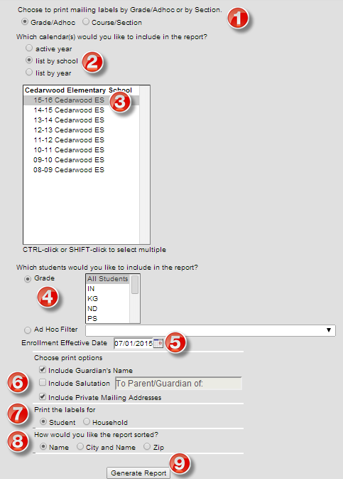
Mailing Labels can be generated for next year’s students. In the 16-17 school year, go to Census > Reports > Mailing Labels.
- Choose to print by Grade or Course Section.
- Select the List by school radio button.
- Click on your next year’s school.
- Defaults to All Students. You can select a specific grade level, if needed.
- The Enrollment Effective Date must be 7/1/2016 or after.
- Select print options.
- Select to print labels by Student or Household.
- Select how to sort the labels.
- Click Generate Report.

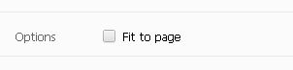
If the labels do not line up properly, there are a couple options, depending on your version of Adobe. In Chrome, the print option should have a Fit to Page Option. Do not check the box.

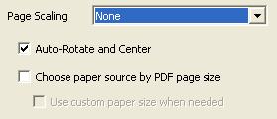
The alternative is to close Infinite Campus in Chrome, and open it in Internet Explorer to run the labels. The print option should display Page Scaling. Try different options in the drop-down menu, as well as the Auto-Rotate and Center box checked and unchecked.

Students returning from Out of the Country
Students who are out of the country for 32 days or more need to see the school nurse prior to returning to school. They are required to receive a TB test before attending school.

Non-grad withdraws that are code 75 (Grad Test Required)

