COLUMBUS CITY SCHOOLS
2015-2016 SCHOOL SCHEDULING (All Levels)

COURSE SCHEDULING INFORMATION: Bilingual Instructional Assistants

LAWriter, Ohio Revised Code - http://codes.ohio.gov/orc/3319.088
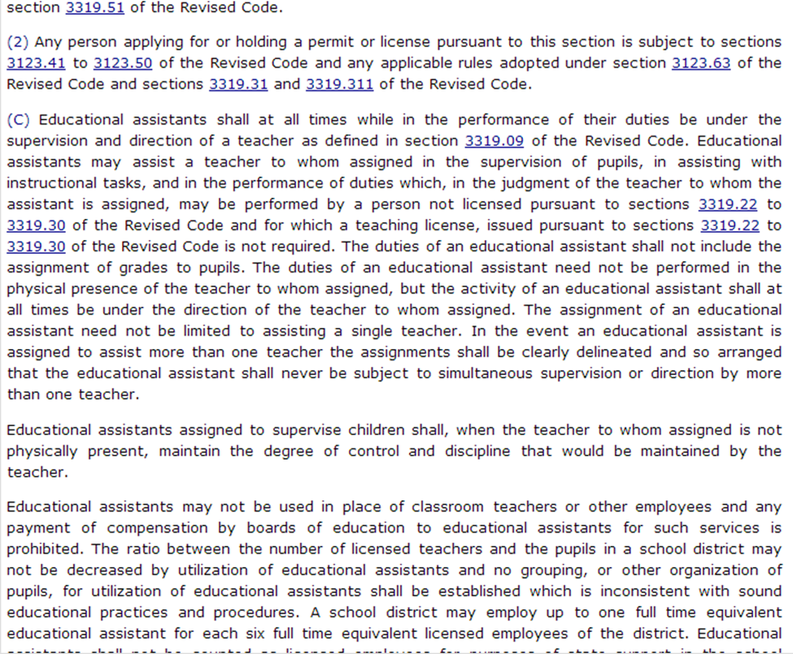

An Instructional Bilingual Assistant (English as a Second Language) assists the teachers and building administrators in providing translations and parental involvement activities. An ESL bilingual assistant also assists teachers in reviewing and reinforcing lessons and skills to pre-functional/beginner LEP students in their native language; performs related duties as requested.
Highlighted Duties
- Provides bilingual support in all parent and targeted ethnic group contacts
- Provides bilingual assistance to school counselors, psychologist, nurses and other personnel
- Establishes rapport with the parents and community members through phone calls, home visits and school conferences
- Provides bilingual instruction to students on a small group or individual basis as needed
- Provides Leveled Literacy Intervention (LLI) or Spatial Temporal Math intervention (ST Math) to small groups of students. Training for these programs is provided through the ESL Department.
  - LLI is a scripted reading intervention kit used with 3-5 students at a time
  - ST Math is a computer-based intervention program
- Provides Push-In support in the native-English speaking classes for LEP students that need assistance
  - “Push-In” is the term that refers to the bilingual assistant working with LEP students within a native-English speaking classroom
- Assists the ESL/ classroom teacher in the preparation of English and native language instructional materials and audio-visual aids

Scheduling Bilingual Instructional Assistants
- The Bilingual Assistant schedule will be determined by the Principal in conjunction with the ESL department and the Bilingual Assistant.
- Bilingual Assistants will be scheduled to provide Leveled Literacy Intervention, ST Math intervention, or Push-In support.
  - Leveled Literacy Intervention should not be scheduled during Language Arts or Math
  - ST Math should not be scheduled during Language Arts
  - Push-in should be scheduled during the periods/blocks where lower level LEP students have been clustered into native-English speaking courses
- If there is a large ESL class of low level students, the Bilingual Assistant may be scheduled to assist the ESL teacher in instruction.
- Bilingual Assistants may be scheduled for a duty period.
  - If the school has a large LEP population, schedule office duty so that the assistant can make/return phone calls to parents in the native language
  - Remember the assistant’s main duty is to assist with instruction and intervention
  - During school hours, the ESL Call Center is in operation at 365-8802 to assist with interpretations over the phone in Spanish, Nepali, Somali & Arabic

