Summary: The IT Self Service page was designed to be a resource for CCS employees with technology-related issues. The following document talks about the basic structure of this area and some of the functions that can be performed by the CCS employees.
For questions regarding this area, its documents, or access issues, please contact the CCS Help Desk at 365-8425.
To Access the IT Self Service Page:
- Click to open Internet Explorer.
- In the address bar, type in https://columbus.atlassian.net/wiki/dashboard.action. A screen similar to the following will appear:
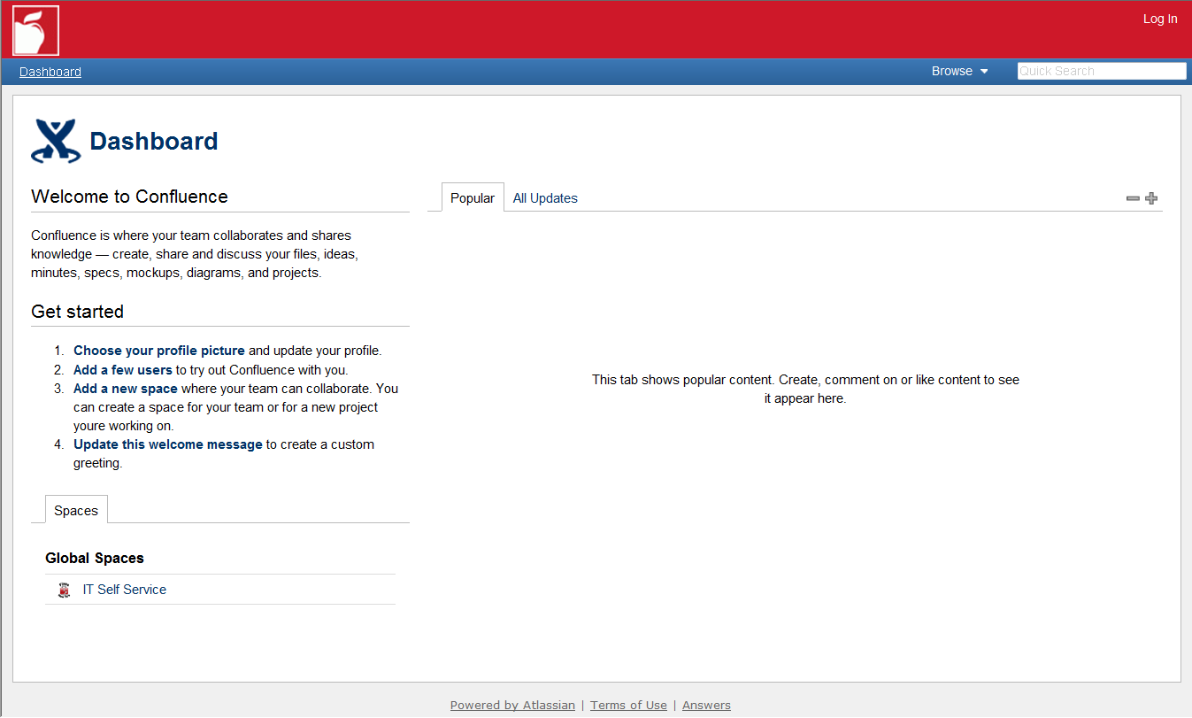
- Click on IT Self Service in the lower left corner of the screen. This will load the IT Self Service page.
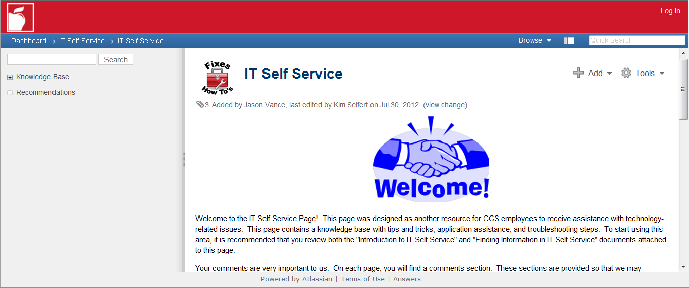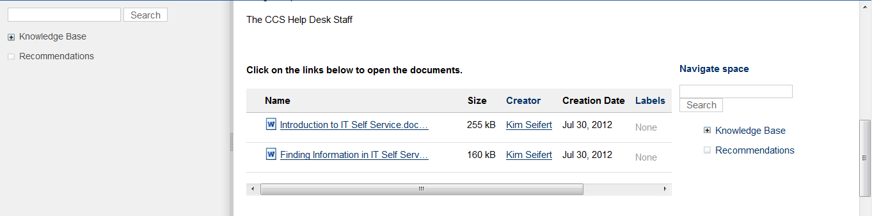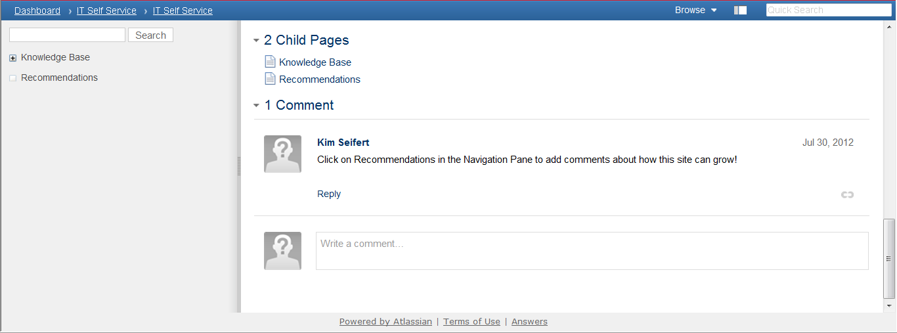
2
3
4
5
1
Homepage of IT Self Service:
- Navigation pane: This pane shows the hierarchy of pages within the IT Self Service area. If there is a plus (+) sign next to an item, this means there are other pages beneath that page. Click on the plus (+) sign to expand this area. Click on a page name to load that page.
- Child Pages: This will display the Pages that are immediately below the IT Self Service Page.
- Comments: This area is open to all users. By typing in comments about a particular document, the Help Desk can make the most of the documentation reviews and updates which happen each year.
- Navigate space: This area functions like the navigation pane.
- Tools: Any rights or privileges to update or add information to the pages is shown here. This area will change with each user, depending on their level of access.

Hierarchy of IT Self Service:
IT Self Service is comprised of a hierarchy of pages. The topmost page is referred to as the Parent page. Each subsequent level of pages off the Parent page is referred to as Child pages. It is possible for there to be multiple Child pages under a single Parent page. It is also possible for there to be multiple Child pages under a single Child page. It is similar to how files and folders are stored on a computer.
What you will not find in the documentation:
The CCS Help Desk tried to include as much information in the self service pages as possible. The Help Desk did not include:
- Any documentation that requires special access or passwords to perform.
- Any documentation that requires adding or configuring network devices (i-devices being the exception)
- Any documentation that contains usernames or passwords used at the Help Desk for the purpose of supporting CCS users.
What you will find in the documentation:
- Common tips and tricks for application usage
- Walkthroughs on some application items
- Links to support documentation for number of applications used by the District
- Common troubleshooting steps performed by the Help Desk that require no special access
Example: You will find information about how to setup Outlook on your i-device, but you will not find information about how to reset a user’s Outlook password.

