Summary: The IT Self Service page allows for 2 unique methods for finding information. This document discusses both of these options.
For questions regarding this area, its documents, or access issues, please contact the CCS Help Desk at 365-8425.
To Access the IT Self Service Page:
- Click on the Internet Explorer icon on the desktop.
- In the address bar, type in columbus.atlassian.net.
- Press Enter. A screen similar to the following will appear:
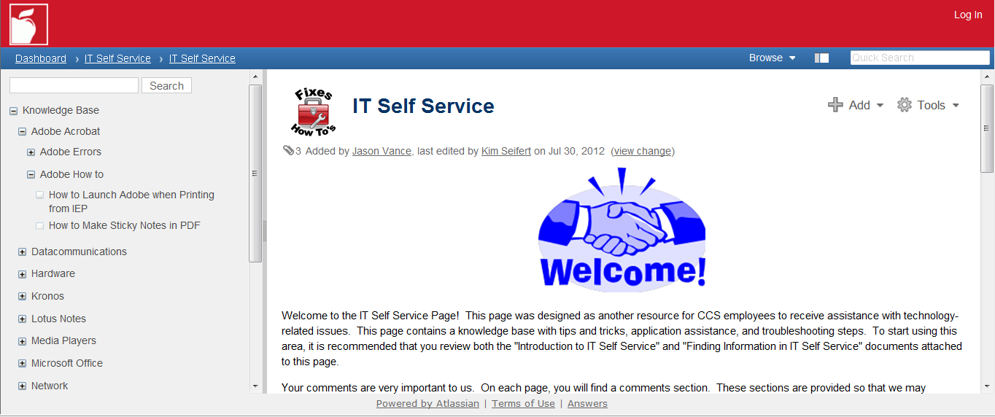
To Use the Navigation Pane:
- Click on plus (+) sign next to the page to be viewed.
- Locate the appropriate page.
- Click on the title of the page to display the page.
NOTE: Users can also click on a page to see the list of child pages below it.
To Use the Search Function:
- In the Search box at the top of the navigation pane, type in a word or words to search on.
- Click Search button.
- A list of documents will appear that contain the word or words.
- Click on the title of the page to display the page.

