INFINITE CAMPUS
PERIOD ATTENDANCE
QUICK GUIDE

\

www.columbus.k12.oh.us/tlc

PERIOD BY PERIOD ATTENDANCE

Teachers:
- Enter attendance electronically for each period, by the end of the period. The last period’s attendance must be entered within 15 minutes of the end of the day.
- If the teacher isn’t able to enter attendance electronically, the teacher will send an Attendance roster (Register Report) to the office. The Attendance Secretary will enter the attendance through the Classroom monitor.

Attendance Secretary:
- Confirm that attendance has been entered each period by teachers through the Classroom Monitor.
- Enter late arrivals using the Batch mode in the Attendance Wizard (see Pages 7-8). This process will calculate minutes accurately for students, but will not interfere with attendance entries for other periods.
- Generate the Caller Report at the end of the first period, or beginning of 2nd period, after all Attendance is entered.

The attendance secretary will change all Absent Unknowns to UNX and all Tardy unknowns to TTC through the Attendance Wizard throughout the day, at the end of the day, or the beginning of the following day following the steps below (see Pages 10 – 13 for detailed steps):

- Attendance Wizard
- Select Date if different than the current date
- Select Period mode
- In Status/Excuse select Absent/Unknown
- Enter the period in the Period Field—this is an extremely important step to prevent absences from being created for students who were not absent that period
- Click Search
- Click Select All
- Current Period: Select the same period that was entered above. It is extremely important that the periods entered here and in the Period Field above match so that absences are being applied accurately.
- Attendance Code: Unexcused
- Save Attendance
Repeat for Tardy Unknown, using the attendance code of TTC: Tardy To Class
Lunch periods for grades 6—12 at most schools are non-instructional and non-attendance. It will look like a gap in the student’s attendance. However, instructional minutes will be accurate.
Period Attendance Entry

- Step One – Generate Register Reports
- Step Two – Enter classroom attendance for substitute teachers and teachers without computer or internet access
- Step Three –Verify classroom attendance has been entered
- Step Four – Process tardies to school using the Attendance Wizard Batch Mode
- Step Five – Print the Caller Report
- Step Six – Absence calls are made to student parents/guardians
- Step Seven – Excuse Notes
- Step Eight – Change “Unknown Absences” to “UNX: Unexcused” by period using the Attendance Wizard
- Step Nine – Change “Unknown Tardies” to “TTC: Tardy to Class” using the Attendance Wizard Batch Mode
- Step Ten – Check students out of school early using the Attendance Wizard Batch Mode
- Step Eleven – Filing and Storing Attendance Excuse Notes
- Step Twelve –Reports
  - Summary Report
  - ADA and ADA Detail Report
  - Day Count Report – Perfect Attendance w/no Tardy marks
  - ACTR
  - Behavior Attendance Audit Report
  - Consecutive Absences

STEP ONE – REGISTER REPORT (aka Attendance Rosters)
There are 3 different attendance rosters (aka Registers) that can be generated. If the attendance roster is being generated for every teacher for every period, generate the Register report. If students have attendance events entered in Infinite Campus, they will display on the report:

- On the Index tab, click Attendance.
- Click Reports.
- Click Register.
- Enter the criteria for the report:
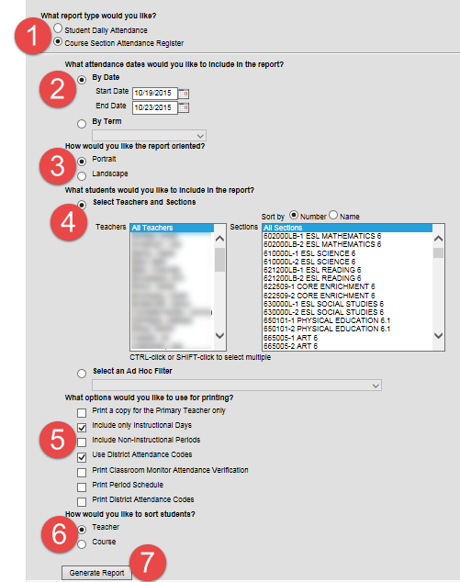
- Select: Course Section Attendance Register.
- Select By Date:
  - Enter the Start and End Date
- How would you like the report oriented?: Select Portrait.
- Select Teachers and Sections: to generate for all classes for all teachers, leave at the default of All Teacher, All Sections.
- What options would you like to use for printing?: Select Include only Instructional Days and Use District Attendance Codes.
- How would you like to sort students?: Select Teacher or Courses.
- Click Generate Report.

STEP ONE, CONT’D – ATTENDANCE REGISTER BY PERIOD
The Attendance Register by Period rosters can be generate for specific periods of the school day. It can also be generated for all period for a specific teacher. This report can be generated for sub teachers:

- Click on Attendance.
- Click on Reports.
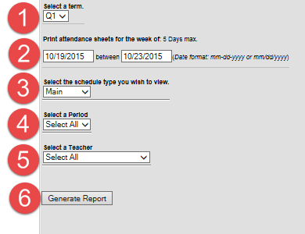
- Click on Attendance Register by Period.
- Select a Term from the drop-down menu.
- Enter the date or date range in either format shown.
- Select the schedule type from the drop-down menu.
- Select a Period defaults to all. A specific period can be selected using the drop-down menu.
- Select a Teacher defaults to all. A specific teacher can be selected using the drop-down menu.
- Click Generate Report.

The report displays as shown below. Please note that at this time, any attendance already entered in Infinite Campus for students will not display on the report:

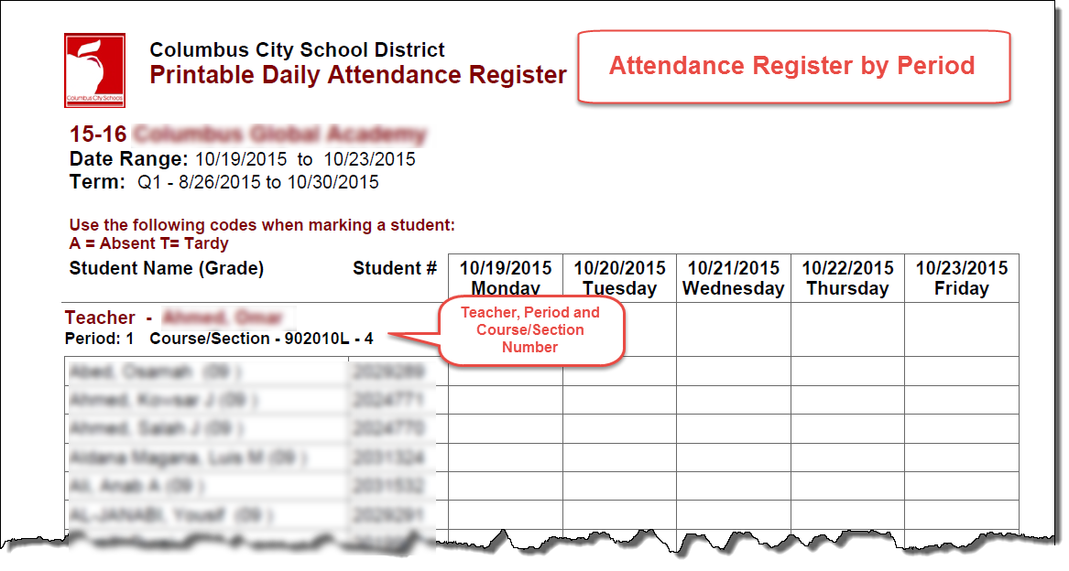
STEP ONE, CONT’D – SUB ATTENDANCE ROSTER
The Sub Attendance Roster can only be generated for one day. However, it can be generated for a range of periods, for specific teachers:

- Effective Date defaults to the current date. The date can be changed by typing in another date or use the date selector.
- Period: Leave blank to generate the report for all periods.
- Click on a specific period to generate the report for one period.
- Use the CTRL key and left mouse button to select specific periods.
- Teacher: Click on the name of the teacher to select the teacher.
- Use the CTRL key and left mouse button to select specific periods.
- Click Generate Report.
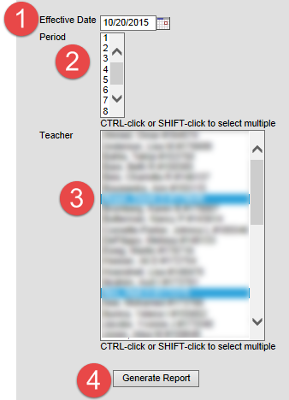

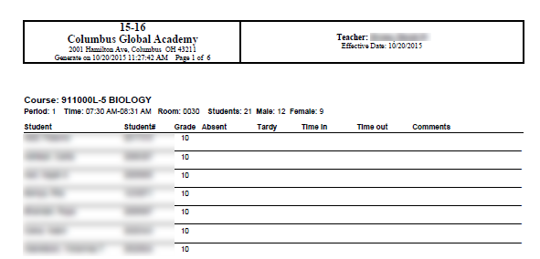

STEP TWO –Enter Classroom Attendance Using Classroom Monitor
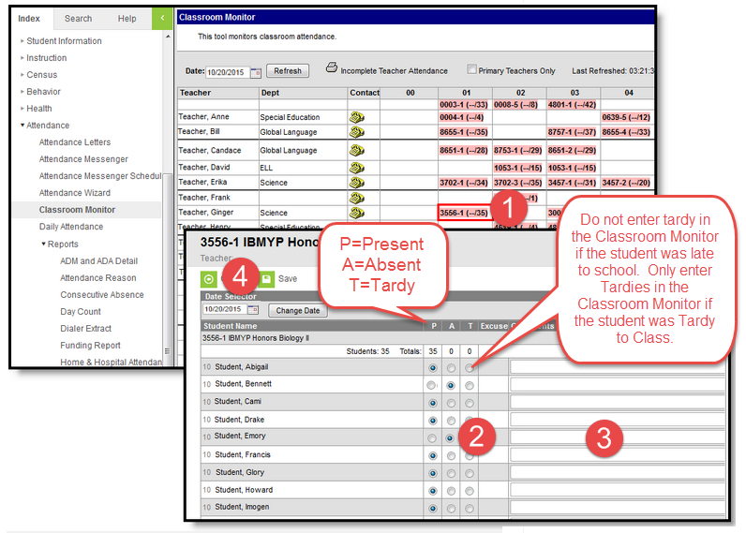
If a paper roster is received by the office for a teacher who is subbing or for a teacher who does not have computer access or the computer is not working, the Attendance Secretary must enter the absences using the Classroom Monitor.

- To the right of the teacher’s name, click on the course section. The screen opens to reflect the teacher view of attendance.
- All students are Present by default. Mark the student’s attendance status by clicking the radio button under A for Absent or under T for Tardy. NOTE: Do not enter tardy in the Classroom Monitor if the student was late to school. Only enter Tardies in the Classroom Monitor if the student was Tardy to Class.
  - If all students are present, skip to Step 4.
- It is optional to enter comments in the Comments field in the Classroom Monitor. Comments entered here will display on the Portal.
- Click Save. The page will refresh and display the Classroom Monitor view with the course section just modified in green.

STEP THREE –Verify Classroom Attendance has been entered
Use the Classroom Monitor to verify that attendance has been entered by the teacher. It is also used by the attendance secretary to enter student attendance for sub teachers or teachers without computer access.

PATH: Index>Attendance>Classroom Monitor

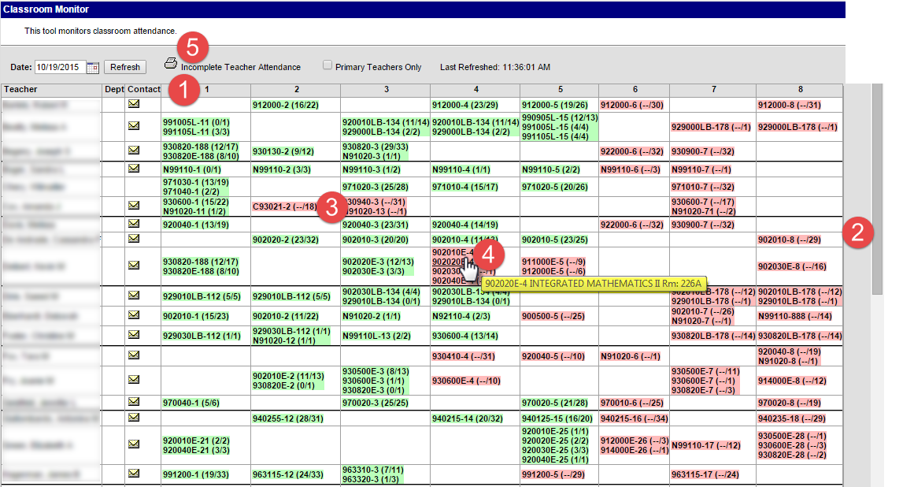
The Classroom Monitor will open to the current date. To change the date, type the date or use the calendar tool to select the date. Click the Refresh button to reload the Classroom Monitor for that particular date.
- Throughout the day, check the Classroom Monitor for completion of attendance for courses. NOTE: some courses may not be an attendance course.
- Use the scroll bar to view the teachers not appearing on the page.
- Sections appearing in pink indicate that attendance has not been taken for that course. Sections appearing in green indicates that attendance has been entered for that course. Notice that the number of students present displays with the number of students scheduled into a course.
- Hover over the course to view the course number, section number, the course name, and the room number.
- Generate an Incomplete Teacher Attendance report for a list of teachers who have not entered attendance, if needed.

STEP Four –Late Arrivals
When a student signs in late to school, the time must be recorded on the Student Late Arrival Log. This log is a paper document that will be used to enter the tardy time and give the Attendance Secretary an indication of how to code the Tardy. For audit purposes, the log must be maintained with the attendance files.

The good news is that a student doesn’t have to be marked absent before entering the late arrival!

Path: Attendance > Attendance Wizard

Late arrivals will be entered using the Batch mode in the Attendance Wizard. This process will calculate minutes accurately for students, but will not interfere with attendance that may have been entered by teachers for other period(s).

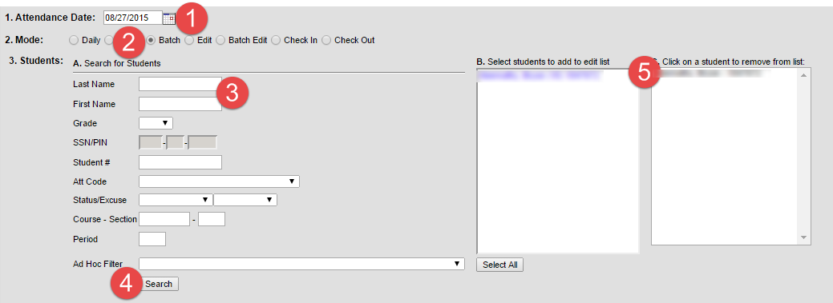
- Date: defaults to the current date, but can be changed by typing in the date or using the Date Selector
- Mode: Select Batch
- Students: Search for the student by name.
- Click Search.
- The Search results will appear in Columns B and C if you search for an individual student. If you search for multiple students, you must click on their name in Column B to move them to Column C, after each search.

STEP Four, cONT’D –Late Arrivals
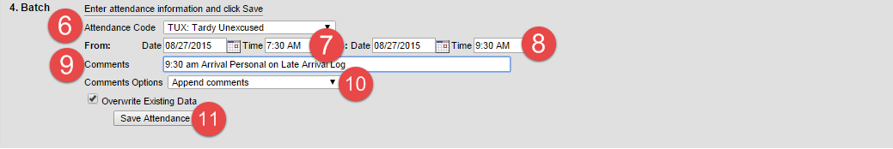
- Select the attendance code of “TEX: Tardy Excused” or “TUX: Tardy Unexcused”, based on documentation on the Student Late Arrival Log and/or documentation from the parent.
- From Date is the date the student reported late to school; From time is the time school begins for the day.
- To Date is the date the student reported late to school; To time is the time the student arrived at school, recorded on the Student Late Arrival Log. The system will calculate the time the student was absent from school and will calculate the minutes present.
- Enter the time the student arrived at school in the Comments field. Enter additional comments as applicable.
- Comments Options: Append comments.
  - Make sure that Overwrite Existing Data is marked.
- Click Save.

IMPORTANT

- In the Comments field, enter the time the student arrived at school first, followed by additional comments, if applicable.

STEP FIVE – CALLER REPORT
Generate the Caller Report before changing unknown absences to unexcused. This report is used to make calls to the homes of absent students. File this report with the Summary Report, Late Arrival Logs, Early Leave logs in the Attendance File.

Index Tab > Attendance > Daily Attendance

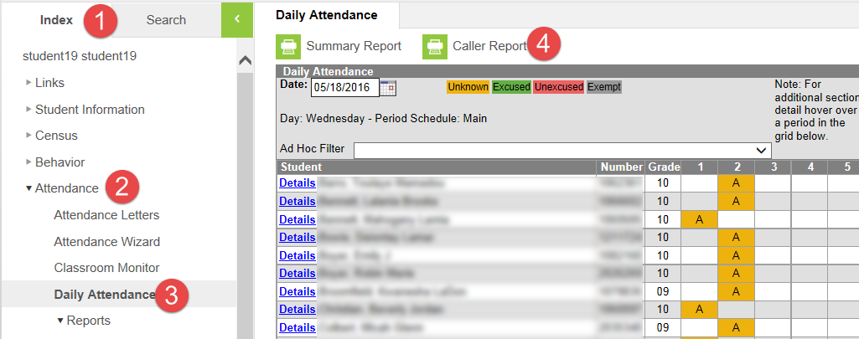
- Click on the Index tab.
- Click Attendance
- Click Daily Attendance.
- Click Caller Report.

The Caller Report will generate with a list of students who have an Unknown absences for any period until the time the report is being generated.

The report includes the guardian information, including name and contact numbers.

STEP SIX – CALL HOME OF ABSENT STUDENTS
Each school is directed to have an Attendance team. Designed member(s) of the team are to make phone calls to the parent/guardian of students absent the current day.

The Caller Report (generated above) is an excellent tool to use when making the calls.

STEP SEVEN – EDITING ATTENDANCE REASONS
The Daily Attendance tool allows a user to see at a glance all students who have an attendance event (absence/ tardy/early leave etc.) for a selected day. From here, a user with the proper rights may also edit an attendance event.

PATH: Index>Attendance>Daily Attendance

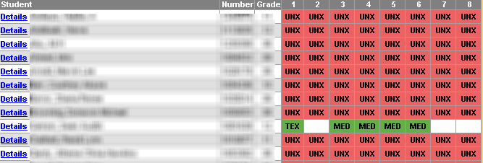

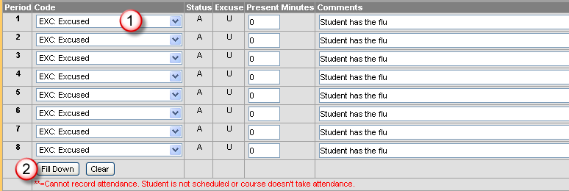
When a parent calls in to excuse the absence for that day and the student’s attendance has already been marked as an unexcused absence, the user can click on the attendance code to make edits.
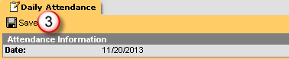
- Select the Attendance code from the drop-down list.
- Click Fill Down (Note: do not use th Fill Down feature if there is not an absence entered for every attendance period.)
- Click Save at the top of the tab.
NEVER CHANGE EXCUSED & UNEXCUSED MARKS TO TARDY MARKS ON THIS SCREEN. THE PRESENT MINUTES WILL NOT CALCULATE FOR THE STUDENT.
Keep all attendance notes in a separate folder for each student. The notes are to be kept at the school until further notice. DO NOT DESTROY!

STEP EIGHT – CHANGE UNKNOWN ABSENCES TO UNEXCUSED (BY PERIOD)

ATTENTION!!!
IT IS CRITICAL TO FOLLOW EACH STEP BELOW. MISSING JUST ONE STEP CAN CAUSE IMMENSE ATTENDANCE ERRORS.

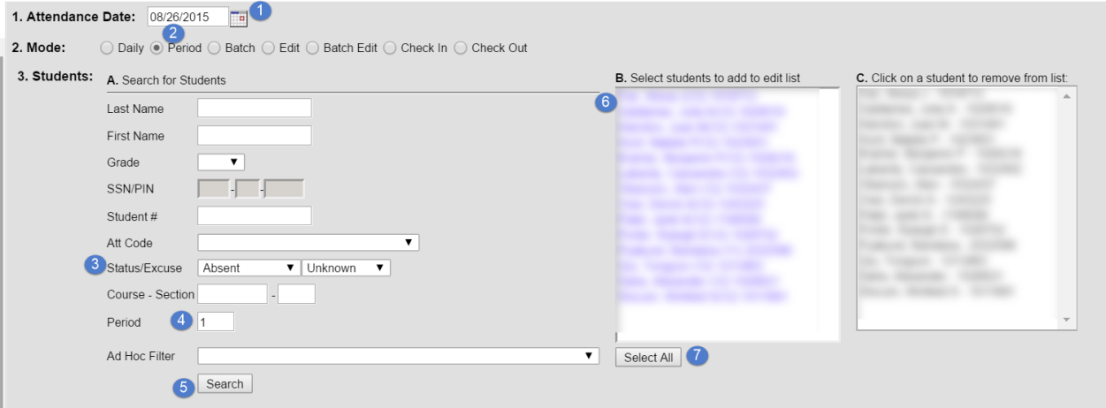
Path: Attendance > Attendance Wizard
- The current date will automatically be entered into the date field. This can be changed to create or edit attendance events for any attendance date. You can either type the date in the mm/dd/yyyy format or choose the date from the calendar by clicking on the date selector.
- Choose the Period Mode radio button.
- Status/Excuse: Choose Absent/Unknown.
- **Enter 1 in the Period field**. IT IS CRITICAL TO ENTER THE PERIOD BEING EDITED.
- Click Search.
- All student marked Absent Unknown during Period 1 will appear in Column B.NOTE: To remove a student from Column C, click on their name to move it back to Column B.
- Click Select All to move all students from Column B to Column C. Only these students in Column C will be affected by this process.
Steps number 3 and 4 above are critical to roll absences entered by the teachers or by the attendance secretary using the Classroom Monitor FOR ONLY THE SPECIFIED PERIOD.

STEP EIGHT, CONT’D – CHANGE UNKNOWN ABSENCES TO UNEXCUSED (BY PERIOD)
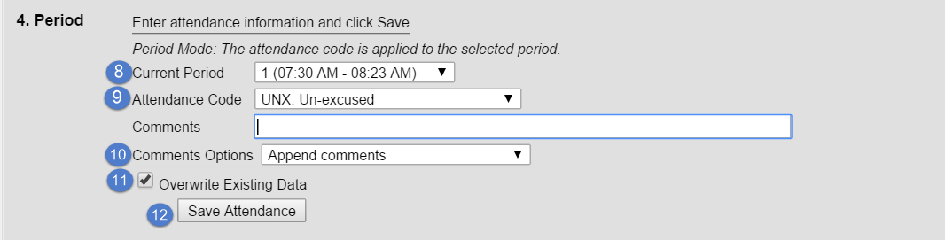
- ** Select Period 1 from the Current Period drop down menu. IT IS CRITIAL THAT THIS PERIOD MATCHES THE PERIOD YOU CHOSE IN STEP NUMBER #4 ABOVE.
- Select UNX: Unexcused from the Attendance Code drop down menu.
- Leave the Comments field blank in this step. Leave the Comments Options default of Append Comments.
- Make sure Overwrite Existing Data is checked.
- Click Save.
REPEAT THIS PROCESS FOR THE REMAINING PERIODS OF THE DAY, SUBSTITUTING THE CORRECT PERIOD: For Period 2, enter 2 in the Period field and Choose 2 in the Current Period field, etc. Any mismatch will result in incorrect data being entered.

Step number 8 above is critical to roll absences entered by the teachers or by the attendance secretary using the Classroom Monitor FOR ONLY THE SPECIFIED PERIOD.

STEP NINE – CHANGE UNKNOWN TARDIES TO TARDY TO CLASS (BY PERIOD)
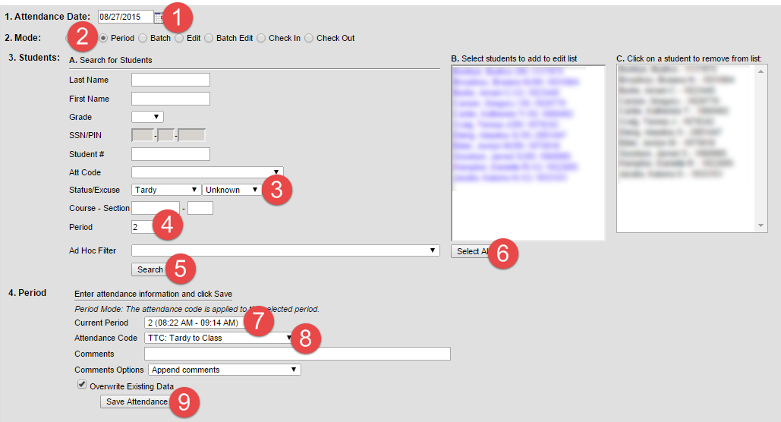
- Attendance Date: Defaults to the current date. The date can be changed by typing in the new date or using the Date Selector.
- Mode: Select Period mode.
- Status/Excuse: Select Tardy and Unknown from the drop-down menus.
- Period: Enter the period being updated in the Period field. IT IS CRITICAL TO ENTER THE PERIOD BEING EDITED
- Click Search.
  - Students with unknown tardies will display in Column B.
- Click Select All to move the students into Column C. Only students who’s name is in Column C will have the attendance edited.
- Current Period: Using the drop-down menu, select the same period that was entered in #4 above. IT IS CRITIAL THAT THIS PERIOD MATCHES THE PERIOD YOU CHOSE IN STEP NUMBER 4 ABOVE.
Tardy to Class is NOT tardy to school. If a student is tardy to school, see Late Arrivals on Page 7 and 8.

- Attendance Code: Select TTC: Tardy to Class from the drop-down menu.
  - Comments Options: Append Comments.
  - Overwrite Existing Data: Leave the box checked
- Click Save Attendance.

Repeat the steps above for each period of the day as attendance is completed.
step ten - Early Leaves
When a student leaves school early, the time must be recorded on the Student Release Log. This log is a paper document that will be used to enter the leave time and give the Attendance Secretary an indication of how to code the early leave. The log must be maintained with the attendance files.

Just like late arrivals, early leaves will be entered using the Batch mode in the Attendance Wizard. This process will calculate minutes accurately for students, but will not interfere with attendance that may have been entered by teachers for other period(s).

To prevent inaccurate data entries, enter Early Leaves at the end of the day. If a student leaves early then returns, the time of leaving and the time of arriving will be recorded accurately.

Path: Attendance > Attendance Wizard

- Date: defaults to the current date, but can be changed by typing in the date or using the Date Selector
- Mode: Select Batch
- Students: Search for the student by name.
- Click Search.
- The Search results will appear in Columns B and C if you search for an individual student. If you search for multiple students, you must click on their name in Column B to move them to Column C, after each search.

step ten, CONT’D – Early Leaves

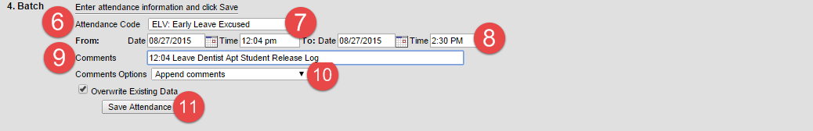
- Enter the EXC: Early Leave Excused or EUX: Early Leave Unexcused.
- From Date is the date of the early leave; From Time is the time the student signed out.
- To Date is the date of the early leave; To Time is the time school ends for the day.
  - Enter the leave time in the Comments field, along with any additional comments to record.
- Comments Options: Append comments
- Leave Overwrite Existing Data checked.
- Click Save Attendance.
Enter Early Leaves at the end of the day, as sometimes students may return from an appointment.

step ELEVEN – FILING AND STORING ATTENDANCE NOTES AND DOCUMENTS
Every school is to have an attendance file for the following documents:
- Summary Report
- Student Late Arrive Log
- Student Release Log
- Route Lists of late bus arrivals
- Fields trips, etc.
- Attendance Notes

In the file, each student with attendance events is to have a folder for parent/guardian notes, (Daily Attendance Call In) Parent/Guardian Absence Notification via Telephone logs, and other appropriate attendance documentation for the current school year.

The attendance file is to be kept at the school until further notice.

step TWELVE – REPORTS

- Summary Report
  - Generate every day
  - File with Attendance files
- Period Count
  - Generate for a count of PAA’s
- ADM and ADA Detail
  - The ADM and ADA report provides the number of students present and absent for specific dates.
  - The Attendance Percentage is also available on this report.
- Behavior Attendance Audit
- Ad Hoc Reports (Index > Ad Hoc Reporting > Data Export)
  - Student ATT Unexc Absent Today w/Home Phone – can be generated if the Caller Report was not generated before changing unknown absences to unexcused.

