Summary
This document contains information about using the CA-Unicenter Customer View. This view is limited to the current fiscal year (7-1-XX to 6-30-XX). This document contains information for the Ticket Status view.

Access/Rights
Anyone can use the Ticket Status view. The user must have the ticket number from the Help Desk. Since this is view-only access to the CA-Unicenter application, the username/password information does not have to be protected like many of the other CCS applications.

Use of View – Ticket Status View
- Open browser.
- Access the IT Self Service homepage.
- Under Quick Links, click on My Ticket Status. The following screen will appear:
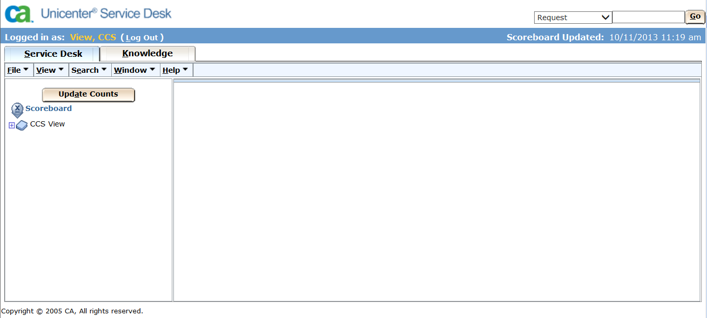
To search for a specific ticket, type in the ticket number and click Go.
This box appears on ticket screens as well, so it is possible to search for additional tickets without returning to the main screen.
Click the Log Out link in order to leave this system screen.
- Type in the ticket number in the Request box.

- Click Go. The following screen will appear:
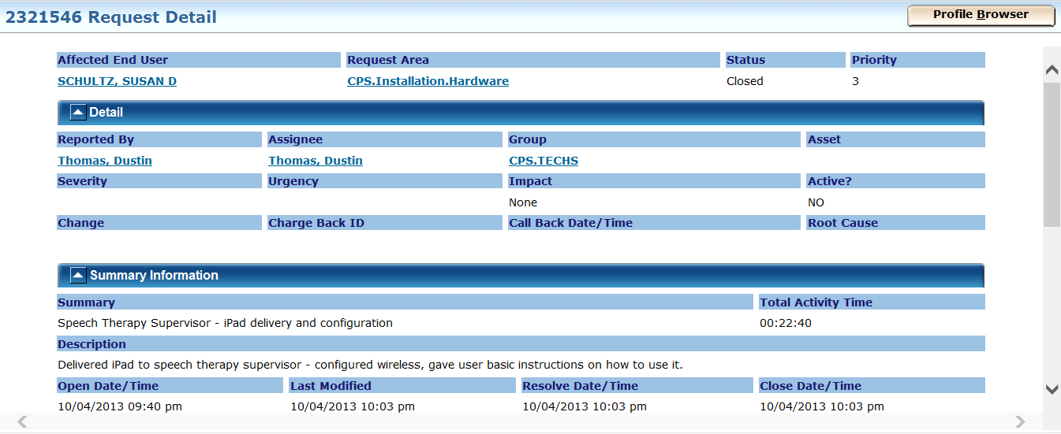
The ticket is broken into 2 distinct sections: The top section has the summary information about the ticket including status, request area, location, Problem Summary and Description.
The bottom section (1.Activities tab) contains all the notes history for the ticket, including any attachments that were attached to the ticket.
The Attachments Tab may contain screen captures of errors that the Help Desk copied from the computer. Press CTRL+click on the attachment to launch it.
Click on the Close Window (upper right) link to return to the main screen; OR search for another ticket in the Request box.
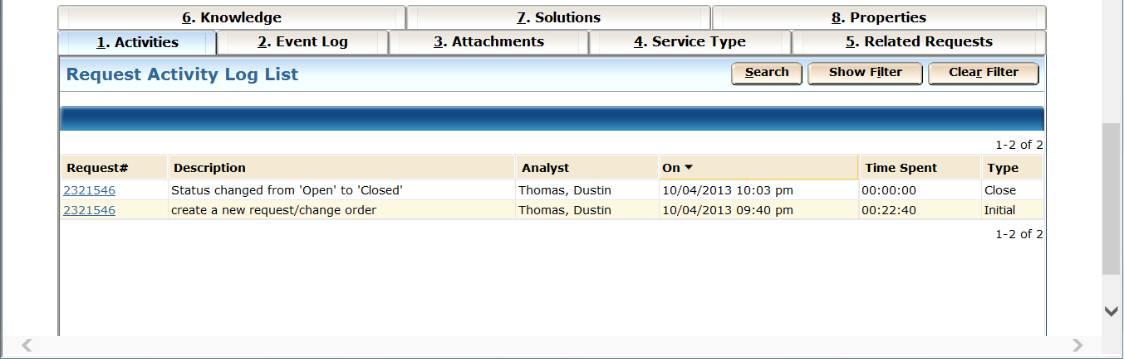

Ticket Status – Ticket number does not exist
- If you receive the following screen, it is because that ticket number does not exist. Please call and verify the Request Number with the Help Desk at x8425.

