Junk Email Options
NOTE: This document applies to the Outlook client. This document to help prevent good emails from going to the 'Junk' folder.
From any folder in the Outlook client do the following.
Right click on any email, click ‘Junk’ then click ‘Junk E-mail options…’.
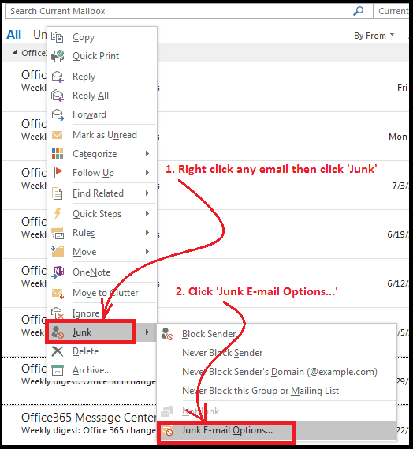

Select the option as shown below.
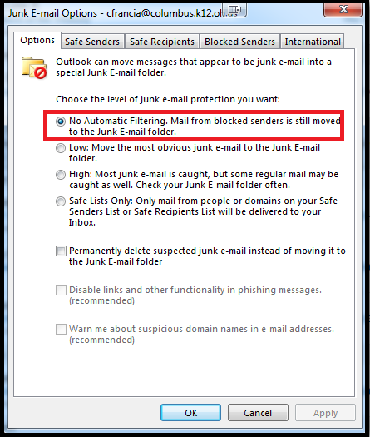

Check all the folder tabs to see if they are set correctly.
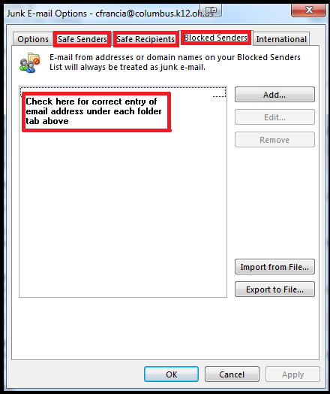

Next Check ‘Rules’ to see if they are set correctly.
In the top menu ribbon click ‘Rules, Manage Rules & Alerts…’
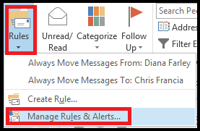
Check if your rules are set properly. You may or may not have any rules set up.
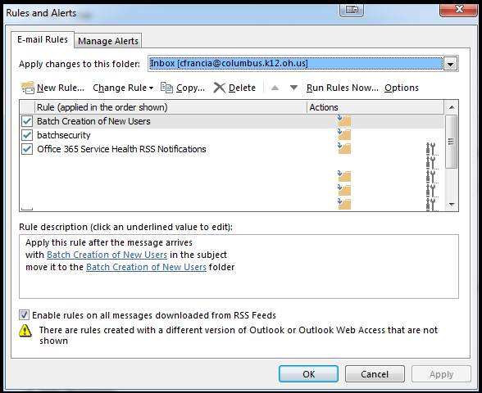

Restart Outlook and check for Future emails going to the Junk folder.

