Infinite Campus Support Training Documentation
Course Name: Attendance Training (Secretaries/Sub Secretaries)
Last Revision Date: February 2, 2022
Description: The Attendance module contains all tools necessary to properly enter student attendance information, maintain historical attendance records and generate reports and letters related to student attendance. At the end of this session, the participants should:
- Understand the importance of taking attendance daily for each student;
- Understand how to enter attendance rosters, logs, and notes;
- Understand attendance codes and know when to use each code.
Contents
Accessing Infinite Campus for this Course 2
Infinite Campus Support 2
PSW (Public School Works) 4
Attendance Office Preparation 5
Attendance Accountability 5
Certify Data Scorecard 6
Global Connect 6
Teachers Role in the Attendance Taking Process 6
Secretaries Role in the Attendance Taking Process 7
Attendance Wizard 8
Common Attendance Events 11
Attendance Forms 13
Attendance Files 15
Attendance Notes 17
Attendance Codes 18
Parent Authorized Absence Codes 19
How to enter a PA Limit Reach Flag 19
Behavior Codes 21
Selecting an Attendance Code 21
Attendance Rosters 22
Attendance Register by Period 23
Sub Attendance Roster 23
Course Section Attendance Register Report (Register Report) 23
Attendance Reports 24
Unable to Locate Student Checklist 26
House Bill 410 – Addressing Habitual Truancy 26
Correcting Attendance Errors 28
Course Blockers 33
Attendance Course Blockers 33
Non-Attendance Course Blockers 34
Reminders 35

Accessing Infinite Campus for this Course
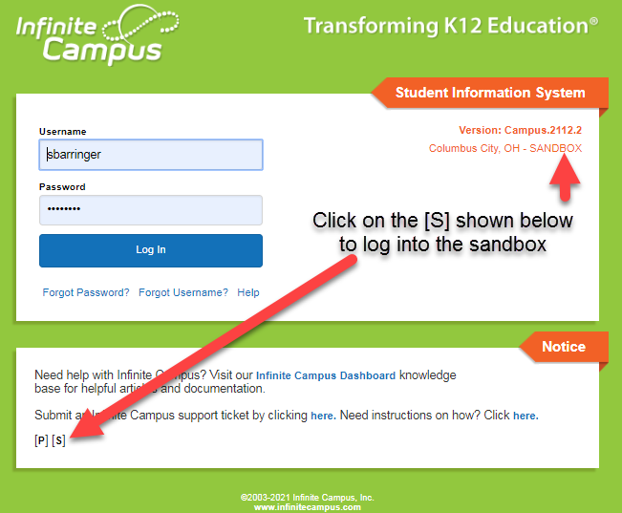
To practice using the skills outlined in this packet, users will log in to the Infinite Campus Sandbox. The sandbox is a test environment used to practice CCS Attendance procedures in a safe space that will not affect live student data. Never log in to Infinite Campus more than once IN THE SAME BROWSER!
When logging in to the sandbox, use the same active directory username and password that you would use to log in to the live version of Infinite Campus.

Infinite Campus Support
There are four main options to obtain support for Infinite Campus users:
Infinite Campus Dashboard – Built for CCS Users
The Infinite Campus Dashboard is our virtual knowledge base of instructions and information. It was created by Columbus City Schools specifically for our users. It includes instructions, videos, and guidelines on how to complete tasks specific to our District in IC. This is your primary resource to receive assistance with IC.
To access the Dashboard:
- Go to the CCS public webpage, click on the “Staff” link at the top of the page. On the Staff page, click the “Infinite Campus Dashboard” link in the second column of Staff Quick Links.
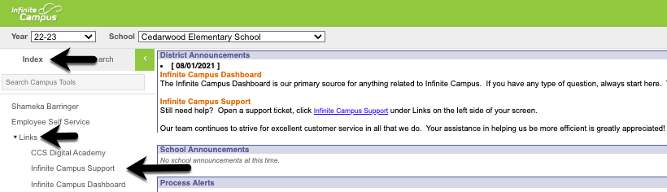
- Or log in to IC, click on the Index tab, click Links, and select Infinite Campus Dashboard.
Infinite Campus Support Ticket – Quickest way to get Support
If you are still unable to get your question answered from the dashboard, please enter a support ticket with as much detail as possible.
Please keep in mind, this is the fastest and most efficient way to receive help from our Infinite Campus Support Team.
You can find the instructions for how to submit a ticket on the Infinite Campus Dashboard, as well as a link to put in a ticket on our CCS public Staff webpage, and as a direct link (Infinite Campus Support) in Infinite Campus.
Student Data Specialists (SDS)
The Student Data Specialists are a source of support and guidance regarding student data and its interactions with IC and associated support systems for various building staff. They visit the schools on a regular basis throughout the school year and can provide on-site training sessions and guidance on the reconciliation of errors identified through Certify and IC reports.
The SDS team represents schools based on their region assignments. All six regions in CCS have a team of two SDS team members assigned. Check the list of regions and staff to find the SDS for your building.
Campus Community – Not CCS Specific
This is the knowledge center that was created by Infinite Campus. It shows instructions on how to use their core product.
To access Campus Community:
- Log in to IC, click on the app switcher (icon made of nine little boxes at the top of the screen) and select Community. You may have to log in the first time that you enter this site, however, you will never be asked to authenticate again after this instance.
Attendance Challenge #1:
- Open the Infinite Campus Dashboard and find the section about Attendance.
- Find the topic labeled “Attendance for Teachers”.
- Click on the section “ES Teachers – Entering Attendance”.
- Read the text on the page.
- Do elementary school teachers enter a tardy for students if they are late to school?
- T or F? – Teachers must save attendance each day, even if all students are marked present.

PSW (Public School Works)
To provide efficient, specialized, online training, Columbus City Schools contracts with PublicSchoolWorks to offer all staff access to electronic professional development opportunities.
Every year, all staff utilize the Behavior, Scheduling, and Attendance modules in Infinite Campus are required to complete a knowledge assessment and pass it with an 80% or better score in PSW. All assessments must be taken yearly to maintain tool rights to enter data into IC. Those who have not completed all their required assessments will have security rights revoked from these modules until ALL required assessments have been completed successfully.
To access the PSW site, go to the CCS internet page, click on Staff, and follow the directions. To log in to PSW, your username is whatever is in front of the @ sign in your CCS email address (including numbers). Your password is your Employee ID number.
If you are not able to log into PSW, please email PublicSchoolWorks@columbus.k12.oh.us with your full name and employee ID number to request access.

Attendance Office Preparation
When preparing to start work in the attendance office, keep the following reminders in mind:
- If you are a substitute secretary, submit an Infinite Campus Support Form (Ticket) to report what school you are assigned to for the day so that tool rights can be granted.
- Keep copies of the Student Absence Notification form near the telephone so they are easily accessible when a parent/guardian calls to report an absence.
- Generate substitute attendance rosters for absent teachers. Attendance taken manually MUST be completed on an Infinite Campus generated roster. Do not accept hand-written attendance rosters.
- Each teacher responsible for recording student attendance should have an attendance folder. The attendance folder will be used to receive attendance notes or distribute information to teachers.
- A new Late Arrival and Student Release log must be used daily with the current date indicated at the top of each page.

Attendance Accountability
Every Minute Counts! The key to our student’s success is attendance in school. Columbus City Schools takes attendance on every student every day! All students arriving after the school's designated start time must be recorded on the Late Arrival Log. Likewise, all student's leaving before the end of the school day must be recorded on the Early Leave log. It’s critical that students check in with the Attendance Office when they arrive.
Students who do not have a schedule are not able to have attendance taken. Students must be scheduled appropriately to have attendance entered and reports generated.
Students that are actively enrolled in your building are allowed to attend school. If a student is actively enrolled in another building (not in your building) they must attend the building at which they are actively enrolled. If a student is present at your building but not enrolled, you need to contact the parent/guardian and have the student picked up from your building.
If you cannot contact a parent/guardian, please keep the student on site and contact Safety and Security at (614) 365- 5638 to complete a house check and inform the parent/guardian that their child needs to be picked up from school.
If the student is not actively enrolled at any Columbus City School, please direct the student and parent/guardian to Central Enrollment to complete the online registration and schedule an enrollment appointment.

Certify Data Scorecard
Certify promotes a daily, proactive process by an automatic reading of Infinite Campus each night. Email alerts are sent to notify school personnel about specific data issues that need to be reviewed, monitored, or corrected. It is important to review and make any applicable corrections for errors reporting on Certify.
Each rule in your scorecard looks at specific data and makes sure that it is valid. If it appears on your scorecard, it needs to be corrected. The prescription page in the Dashboard lists all the rules defined in Certify, and a 'prescription' for how to fix them.

Global Connect
Global Connect is the District’s automatic phone dialer. It will call the homes of students who have an unexcused absence(s) for any period of the day. The phone dialer will call between the hours of 5:00-9:00 p.m.
Please note that the phone dialer does not replace the responsibility of making a personal phone call when a student does not come to school. It is a safety issue to ensure that we connect with families in the morning, especially at the elementary level.

Teachers Role in the Attendance Taking Process
All teachers will enter attendance electronically in Infinite Campus.
- Elementary teachers must have attendance taken by 9:30 a.m. every day.
- Secondary teachers must have attendance taken by the end of every period except for the last period of the day. For the last period of the day, attendance should be taken and submitted within 15 minutes of the end of the period.
The following are exceptions for entering electronic attendance:
- substitute teachers
- teachers without access to a computer at the time attendance is required
- the student information system cannot be accessed due to power, network, or system outages.
All teachers are to have a paper roster in the classroom in the event of such exceptions. Handwritten rosters will not be accepted. The teacher will send a roster to the office (secondary teachers should send the roster before the end of each period).
All substitute teachers will have an Infinite Campus student roster generated for them by the building secretary. Once the attendance is recorded on the roster, it will be submitted to the secretary. The secretary will enter the attendance through the Classroom Monitor and will file the attendance rosters in the appropriate daily attendance folder.
Teachers only have access to enter attendance for the current day. They cannot enter or edit attendance for previous or future days. Teachers will be able to view attendance entered by the office but are unable to override that attendance.
If a teacher has an attendance correction for a previous date, they should request a correction be made by submitting the student’s information and the nature of the error to the secretary in writing (preferably email). The secretary will then make any necessary corrections according to Board guidelines.
Attendance Challenge #2:
- Global Connect calls the homes of students who have an ______________ for any period of the day.
- What time do elementary teachers have to have their attendance completed by?
- What are the exceptions to entering electronic attendance in Infinite Campus?
- When a substitute turns in an attendance roster to the secretary, what tool in Infinite Campus is used to enter that attendance?
- A teacher enters an absence for a student on Tuesday who was present in class. After discovering the mistake, what steps does the teacher need to take to have the error corrected?

Secretaries Role in the Attendance Taking Process
Secretaries are responsible for most of the data input for student attendance. The secretaries will:
Step 1: Confirm that attendance has been entered by all teachers daily through the Classroom Monitor.
    - Check each period for Secondary buildings.
    - Check at 9:30 a.m. for Elementary buildings.
Step 2: Enter attendance rosters into the Classroom Monitor. Attendance is manually entered for:
    - Substitute teachers
    - Teachers without access to a computer
    - All teachers when the student information system cannot be accessed
    - File all paper rosters that are entered into the Daily Attendance folder for that day.
Step 3: Enter late arrivals using the Attendance Wizard.
Step 4: Generate the Caller Report (MUST BE DONE BEFORE ROLLING ATTENDANCE)
    - After all attendance has been entered by the teachers and all late arrivals have been processed.
    - Make phone calls to the homes of students who are absent for the day.
Step 5: Enter and upload any attendance notes.
Step 6: Change all Absent Unknowns to UNX through the Attendance Wizard.
    - This process is called ‘rolling’ the attendance.
    - This is only done by Elementary School secretaries.
    - Do not roll attendance for Secondary and 6-8 grade in K-8 Schools.
Step 7: Enter the early leaves using the Attendance Wizard.
Step 8: File or upload all attendance documents.
    - View the section of this document called “Attendance Files” to locate the correct location to file all attendance documents.

Attendance Wizard
The Attendance Wizard tool allows the Attendance Office to quickly create or change attendance data for an individual or a group of students. It is the workhorse of the attendance tools in Infinite Campus.
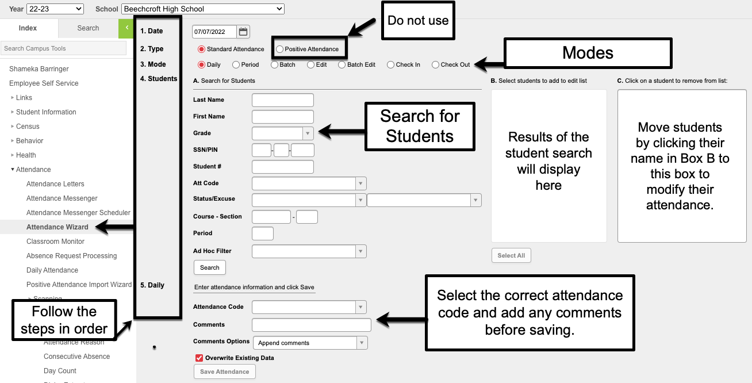
The Attendance Wizard has the user enter information in a certain order. The steps to enter information are numbered on the wizard. It is important to remember if you start at Step #5 and then go back to change the mode in Step #2, the previous data you entered in Step #5 will be removed and will need to be added again.

Information entered in the wizard will modify student attendance. Check and verify all information entered in the wizard before entering save. It is a good idea to remind yourself to check over the data you have entered for accuracy.
It is good practice to always check your data before saving. However, if an error is made, please submit a Campus Support Form for assistance as soon as possible. Do not hesitate to seek help if an error is made, we are here to support you!

In the meantime, here is a little rhyme to help remind you to check all the fields before saving:
I checked the date,
I chose the mode,
I’ve picked the kids,
Now here’s the code.
Entered comments,
The date and time,
Now hit Save,
And finish the rhyme.
There are different modes available in the Attendance Wizard: Daily, Period, Batch, Edit, Batch Edit, Check In and Check Out.
Below is a description of each mode found in the Attendance Wizard. For directions on how to enter attendance using each mode, please visit the Infinite Campus Dashboard.
- Daily Mode – Used by Elementary Schools. Do not use for MS/HS.
  - Records student attendance for an entire day.
  - Used to “Roll” attendance from an Unknown Absence to an Unexcused Absence.
- Period Mode - Used primarily by Secondary Schools. Not typically used in ES.
  - Record student’s attendance for the selected period.
  - Student(s) will be off campus or will miss class for a selected period only, such as testing during a certain period.
- Batch Mode - Used primarily by Secondary Schools. Not typically used in ES.
  - Secondary schools use this mode to record a tardy or early leave. Add the time and reason in the comments when using this mode.
  - Records student attendance for the entered date range and time range.
  - Can be used when a student will be absent from school for consecutive full days.
  - Student(s) will be absent for a specified date range and time range, or when a student will be absent from school for multiple days.
- Edit Mode – DO NOT USE. NOT USED BY CCS SCHOOL STAFF.
- Batch Edit Mode – DO NOT USE. NOT USED BY CCS SCHOOL STAFF.
- Check In - Used by Elementary Schools. Do not use for MS/HS.
  - Used by elementary schools to check in late arrivals.
  - Student comes to school AFTER having been marked absent for the entire day.
  - Using this mode marks the student as present from the time of arrival through the remainder of the day.
  - Student must be marked absent first for this mode to work.
- Check Out - Used by Elementary Schools. Do not use for MS/HS.
  - Used by elementary schools to check out early leaves.
  - Student leaves school after being in attendance from the beginning of the school day through the leave time.
  - Using this mode marks the student as absent from the time of departure through the remainder of the day.
There are exceptions to certain buildings when using the Attendance Wizard.
- K-6 buildings – 6th graders attending these buildings have their attendance processed the same as the elementary school students in the building. Use Daily Attendance mode to process their attendance.
- K-8 buildings - use Daily Attendance for Grades K-5. Use Period Attendance for Grades 6-8.
Attendance Challenge #3:
Review the scenarios below and draw a line to match them to the mode you would use in the Attendance Wizard to enter the information.
Entering a tardy for a 4th grade student. |  | Check Out Mode
Entering an early leave for a 9th grade student. |  | Edit / Batch Edit Mode
Entering an early leave for a 1st grade student. |  | Batch Mode
Roll all unknown absences to unexcused at Ohio ES. |  | Period Mode
Enter an absence for 3rd period for an 11th grade student. |  | Daily Mode
Get a reminder from Meka never to use these modes. |  | Check In Mode

Common Attendance Events
Late Buses
Students arriving on a late bus must be documented on the route sheet, not on the late arrival log. The route sheet must include the date and time of arrival for the bus, and clearly mark each student that came in on that route.
Attendance code to use: LB
Comment: CCS Trans Issue – (Put the route number and time of arrival)
A route sheet can be printed from Versatrans using these instructions:
- Log in to Infinite Campus
- Click on the Index Tab
- Click on Links
- Select Transportation Info
- Log in to Versatrans using the District Username and Password
  - Username: ccstrans
  - Password: ccstrans
- Click on Reports
- Select Stop Locations Report
- Select the School and the Day
- Select the Route Number
- Click Generate Report
Students who arrive to school using other means of transportation are also coded LB if they were scheduled to ride the late bus. Add these students’ information to the late bus route sheet with the date and time of their arrival.
If an isolated report is made by a parent/guardian that a bus did not show up, or was late/early, this must be verified with transportation. These late arrivals must be coded unexcused until it is verified that there was a bus issue. Follow the procedures for entering late arrivals into Infinite Campus.
When coding the absence, put a comment in that states “CCS Trans Issue” and the route number and time and date the bus arrived. Keep in mind that when entering this information into Infinite Campus:
- Elementary Schools will use Check-In Mode
- Secondary Schools will use Batch Mode
Positive Attendance
Positive Attendance records student attendance on a time basis, indicating the student was present in a class, whereas standard attendance recording indicates the student is absent or tardy from class. This is set up on a course-by-course basis and is used at CCS only for approved courses.
Staggered Start
For kindergarten students being evaluated for class placement during the first three days of school, and pre-kindergarten students whose school calendar does not start with the official District calendar start date, the staggered start exempt code is used to track attendance. (22/23 SY– This information will be entered by the EMIS team)
Senior Graduation Attendance
All 12th grade students that have completed their exams and will not be attending for the last three days of school, should be marked as Class Excused (CLS) for those days per Board Policy 5200.01*.

Attendance Forms
The Attendance Accountability Committee has developed and adopted specific forms for the collection and documentation of attendance information. Examples of each form is included on the Dashboard.
Students who arrive after the official start of school are considered tardy and must sign in, while students who leave before the official end of the school day must be signed out. When a student arrives late or leaves early, they must sign out on the Late Arrival Log or the Early Release Log. Remind parents that we require the following information to be recorded on each log:
- Students First and Last Name (not initials)
- Time of arrival
- Reason for late arrival/early leave”
- Parent/Guardian Signature
All logs listed below are available for viewing and printing on the Infinite Campus Dashboard. Open the dashboard and click on the “Attendance” section on the left of the screen. Under this heading, click on “Attendance Forms”.

Late Arrival Logs - These logs are required and are used to record the date and time students arrive to school after the start of the school day. Students arriving on a late bus must be documented on the route sheet, not on the late arrival log.
- To correctly calculate the minutes a student was absent, when recording late arrivals in the Attendance Wizard:
  - Elementary Schools use Check-In Mode – student must be marked absent in Infinite Campus to use this feature.
  - Secondary Schools use Batch Mode - add the time and reason in the comments section.

Student Release Logs - These logs are required and are used to record the date and time students are released from school before the end of the school day.
- To correctly calculate the minutes a student was absent, when recording early releases in the Attendance Wizard:
  - Elementary Schools use Check-Out Mode
  - Secondary Schools use Batch Mode - add the time and reason in the comments section.
Student Absence Notification Form - This form is completed by any staff member who records a verbal notification of an absent reason from the Parent/Guardian, such as a phone call to the school. Parents and guardians should call the school to report a student’s absence before 9:30 AM for each day a student is absent. The school must maintain documentation of every phone call used to modify an attendance event.
Request for Principal Approval of an Excused Absence Form – this form can only be approved and signed by the Building Principal. There are a few reasons you may need to use this form:
- Absence excuse received more than one week from the date of absence - The parent or guardian must supply the school with a verbal or written excuse within one week of the student’s return. Any verbal or written excuse provided after this time will not be accepted unless approved, in writing, by the principal. If no valid excuse is received, the absence will be considered unexcused.
- Parent Authorized Absence Limit of 9 has been reached - A maximum of nine (9) student absences from school may be considered excused with parental notification. After nine (9) absences, additional information and/or documentation, in addition to the parent notification, may be required for the absence to be excused. Documentation must be reviewed by the principal. If approved by the Principal, the absence will be coded as excused.
- Family Emergency – Initially coded as UNX (Unexcused); A Request for Principal Approval Form can be submitted for approval. If approved by Principal, the absence coding should be changed to EXC (Excused).
- Student is going out of the country.
- Family Vacation - See Administrative Guidelines On Coding For Family Vacations (5200.01). A Request for Principal Approval Form must be submitted for approval.
- Any other non-Board approved reason.
Class Excused Form - Student is not physically present in class but is participating in a school approved activity. Staff will complete this form to capture when a student is absent from class, due to receiving authorized services within the school day. Upload this form in the student's individual attendance repository. This form is not used when a whole class is participating in a field trip. At that time, a class roster is used to record the attendance of the students on the field trip. Students on field trips are still considered class excused. All students who are class excused are coded with the CLS code in Infinite Campus.
Health Services Form - A Student Absence Excuse form to be used by school nurses and health services staff when excusing a student from school. This is a standardized form and will be used district wide.
Attendance Challenge #4:
- Open the Infinite Campus Dashboard.
- Expand the Attendance section to see all the topics underneath this heading.
- Click on Attendance Forms.
- Name four other languages the Student Absence Notification form is translated in.
- Name all the staff members who can sign a Request for Principal Approval of an Excused Absence Form.
- Where should the Health Services Form be filed once it is completed?

Attendance Files
For the purpose of data integrity and validation every school is to maintain two types of files for attendance data. Attendance documentation and filing MUST be maintained in the order outlined below.
It is required that all attendance documentation be stored at the school for 1 year according to the Records Retention Schedule. At the end of each school year, you should store all attendance documentation in an approved box clearly labeled and appropriately stored in your building. (To view the Records Retention Schedule, visit the Infinite Campus Dashboard and view the “Records” section.)
Daily Attendance Files
There should be a physical attendance file for each school day. These files will contain the following documents:
- Student Late Arrival Log for the day
- Student Release Log for the day
- Route Lists of Late Buses for the day
- Field trip Attendance (if applicable)
- Paper Registers/Rosters that are entered for the day.
- All Attendance Reports for the day (Daily Caller Report and Summary Report)
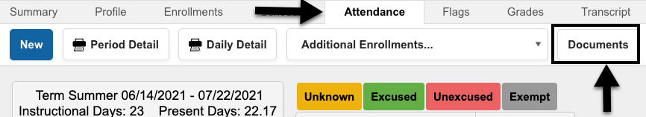
Individual Student Attendance Files
This set of files will contain attendance information for individual students. Documentation for Individual Students must be uploaded to the student's Attendance Repository on the student's Attendance Tab. Once you have uploaded a note and verified that it is in the student’s attendance repository, the note is able to be shredded.
If you receive an absence note with multiple students on the note (siblings), make sure to upload it to each student's respective attendance repository.
The following information should be stored in the student’s Attendance Repository:
- Excuse Notes (Any documentation used to change an absence from Unexcused whether from a parent, medical professional, or agency)
- Completed Student Absence Notification Forms
- Completed Request For Principal Approval of an Excused Absence Forms
- Completed Class Excused Forms
- Completed Health Services Nurse Excuse Forms
- Any documentation used to explain change or correction to attendance for the individual student.
- Printed copies of emails that document attendance corrections.

Attendance Challenge #5:
Draw a line to file the forms below in their correct location.

Eakin ES Late Arrival Log
Absence Note for John Smith
Dr. Note for Nancy Wheeler
Ms. Dean’s Field Trip Roster from Friday
Health Services Form for Joe Blue
Rt 456 Roster of Students on late bus
Caller Report for West HS
This Photo by Unknown Author is licensed under CC BY-NC
Student Repository
Physical Daily Attendance Files

Attendance Notes
Board Policy 5200 - In accordance with statute, the Superintendent shall require, from the parent of each student of compulsory school age or from an adult student who has been absent from school or from class for any reason, a statement of the cause for such absence.

When a student is absent from school for all or part of the day, the absence can be considered excused when the Guardian has notified the school verbally or provided written documentation indicating a board approved reason for the absence.
Absence excuse notes must be received within one week from the date of absence. Only the guardian listed in Infinite Campus may excuse a student’s absence. If a note or phone call is received by someone not listed as a guardian, the absence cannot be excused.
*If the parent reports an absence for any reason other than those listed below, the absence is considered Unexcused and would require principal approval via the Request for Principal Approval of an Excused Absence Form to be considered for an Excused absence.

Board Approved Reasons for a student absence:
- Personal Illness
  - A medical or dental appointment (type of appointment must be specific)
  - A written statement from a physician, dentist, or licensed mental health provider. * An excuse on the Health Services form provided by the school nurse would be considered excused as if it were a doctor’s note. Students that have re-occurring doctor appointments must provide an excuse from each appointment they attend. Blanket excuse notes outlining all the scheduled appointments cannot be used to excuse an absence.
- Family Illness or Medical Appointments
- Death of Immediate Family (limit of 3 days)
- Court Hearing
- Observation of a religious holiday
- College Visit (documentation from the school admissions office required)
The following information must be on all absence excuse notes:
- Student First and Last Name
- Date the note was written
- Date(s) of absence
- Reason for absence/tardy/early dismissal
- Parent/Guardian name and signature. If using the Absence Notification Form to document a phone call, the name of the caller must be indicated on the form (not the relationship).
* If more than one student is listed on an excuse note, the note should be scanned and placed in each student's individual attendance repository.
All excused absences must have the type of documentation on file recorded in the comment section of the absence. The comment should be filled in for each period the excused coding of any other non-Board approved reason.

Attendance Codes
The reason for an absence and the type of documentation received determines which attendance code to use. For example, a teacher providing a list of students on a field trip would be coded as ‘CLS’ or Class Excused. However, a student who has a full day of absence for a medical reason and has documentation of the event received from the parent only would be PMD.
A comment must be entered when any attendance code is used, except for Absent Unknown and Absent Unexcused (UNX). The comment should be entered in each period that is affected by the absence.
Attendance events SHOULD be modified when the reason for the absence or comments are changed. If a student has a parent medical absence coded as a PMD, and the parent provides a doctor’s note (Higher Documentation) two days later, the code should be updated to MED.
To see a complete list of Attendance Codes, their meanings, and the type of documentation required to use the code, visit the Infinite Campus Dashboard.

Parent Authorized Absence Codes
Columbus City Schools Board Policy 5200.01 - Attendance Absence states that a maximum of nine (9) student absences from school will be considered excused with parental notification. After nine (9) absences, additional information and/or documentation in addition to the parent notification may be required for the absence to be excused.
When a parent or guardian provides an absence excuse/note that has a Board approved reason for the absence, and has not exceeded the maximum (9) allowed, then the absence can be coded as:
- PAA – Parent Authorized Full Day Absence
- PAEL – Parent Authorized Early Leave
- PALA – Parent Authorized Late Arrival
- PMD – Parent Medical – Full Day Absence for medical reason
- PMEL – Parent Authorized Early Leave – for a medical reason
- PMLA – Parent Authorized Late Arrival – for a medical reason
Any additional parent notes must be given to the Principal to review, along with a Request for Principal Approval of an Excused Absence Form.
Once the student has reached their (9) Parent Authorized Absence limit, a PA Limit Reach Flag must be added. If the flag is not added, you will receive a Certify violation on your score card. Enter the flag to resolve this violation.
Once a student brings in higher documentation, such as a doctor’s note, for an absence, the absences should be edited from a parent authorized absence to an appropriate excused code such as MED.

How to enter a PA Limit Reach Flag
When students have accrued 9 Parent Authorized Absent codes, a flag can be started. The PA Limit Reached flag will assist users when entering attendance notes.
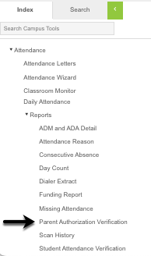
A report listing students who have 4 or more equivalent days of Parent Authorized Absences can be found under the Attendance module in Infinite Campus.
Click on the Index tab, expand the Attendance module, expand Reports, select the “Parent Authorization Verification” Report. Once you have found the student’s that have reached the limit, follow the directions below to add a flag.
- Search for the student. Go to Index > Student Information > General
- Click on the student’s Flags tab
- Click New at the top of the screen. The Student Flag Detail window will open.
- Select the flag “PA LIMIT REACHED” from the drop-down menu. (Hit the letter “P” on your keyboard)
- Enter the current date in the Start Date field.
- Enter the end date – It is recommended that you put the last day of school. The PA LIMIT REACHED flag will expire on the last day of the school year or, if the student brings documentation that lowers the number of absences to less than 9. If this occurs, open the entered flag, and change the date from the end of the school year to the date the documentation was turned in. Failure to enter an end date will result in the flag rolling over to the next school year.
- User Warning: what is entered in this field will display when hovering the cursor over the flag. You do not need to enter any text here.
- Click Save. The flag will display next to the student’s name after refreshing the page.
Students with fewer than 9 days equivalent Parent Authorized Absent Minutes must have PA Limit Flag ENDED.
Users will receive a Certify notification when students have a PA Limit Reached flag but do not have an accumulation of 9 Parent Authorized Absences. If this notification is received, end date the PA Limit Reached flag.

Attendance Challenge #6: LOG INTO THE SANDBOX TO COMPLETE THIS CHALLENGE!
- Run the “Parent Authorization Verification” report for your school.
- Search for a student.
- Navigate to their Flags Tab – Index > Student Information > General > Flags
- Enter a flag for the student that indicates they have exceeded their Parent Authorized Absences as of today’s date.
- Save the flag.
- Open the flag entry you just created and end date the flag using tomorrow’s date.

Behavior Codes
There are some behavior resolutions that will affect attendance for the student. When the resolution is entered, an attendance code will be added to the students’ attendance tab. These codes should not be manually entered on a student’s attendance record.
- RMV - Hearing (Student Removal)
- OSS (Out of School Suspension)
- ISS (In-School Suspension) a.k.a. PEAK

Selecting an Attendance Code
To determine the correct code to use for a student’s absence, let’s look at the graphic on page 22 to decide which group of codes we should be selecting from:
- Unexcused Codes
- Excused Absence Parent Codes
- Excused Absence District Codes
- Exempt Codes
Keep in mind when looking at this graphic:
- Students may need to have the Request for Principal Approval of an Excused Absence Form for excused absences that fall outside of the Board Approved Reasons.
- Students who are participating in an approved school activity will be marked with exempt codes, such as CLS.

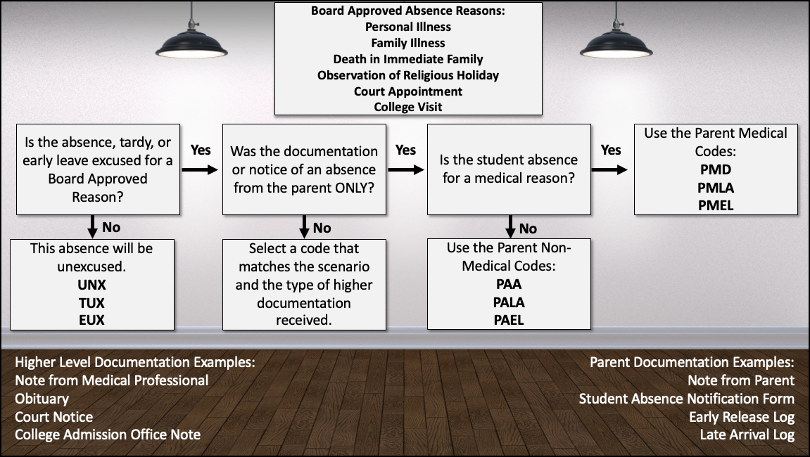

Attendance Rosters
Rosters that can be printed for attendance collection are found on the Index tab, under the Attendance Module, under the reports section. All teachers are required to enter attendance electronically in Infinite Campus. A paper generated roster may be used to record attendance for the following reasons:
- substitute teachers
- teachers without access to a computer at the time attendance is required
- the student information system cannot be accessed due to power, network, or system outages (Infinite Campus is down).
All teachers are to have a paper roster in the classroom in the event of such exceptions. Handwritten rosters will not be accepted. File all paper rosters in the Daily Attendance File.

When taking attendance on these reports it is preferred that the teacher or substitute teacher use the following marks when recording attendance:
- A-Absent
- T-Tardy
These records are routinely checked by the SDS Team, Internal Auditor, and State Auditor. While it may seem easier for teachers to mark attendance with a or an , we ask that they not do so. While using those marks may make sense to your school staff, an auditor checking these records may not understand what a dot or check mark stands for at your school. They will not have the time to personally speak with each teacher about what each mark means. Please suggest all staff use the universal marks.
It is recommended that the register/roster have the teachers’ signature and the date on the bottom for optimal data verification. The Course Section Attendance Register and the Sub Attendance Roster has a signature space already printed on the bottom. The Attendance Register by Period does not, but the teachers can still sign the bottom of the page.

There are the three reports that can be utilized as rosters for recording attendance:

Attendance Register by Period
The Attendance Register by Period rosters can be generated for specific periods of the school day. It can also be generated for all periods for a specific teacher. This report can be utilized for recording attendance for a class when a teacher is unable to enter attendance electronically. When this report is turned in, enter the attendance into Infinite Campus using the Classroom Monitor.

PATH: Index > Attendance > Reports > Attendance Register by Period

Sub Attendance Roster
The Sub Attendance Roster can only be generated for one day. However, it can be generated for a range of periods, for specific teachers. This report can be utilized for recording attendance for a class when a teacher is unable to enter attendance electronically. When this report is turned in, enter the attendance into Infinite Campus using the Classroom Monitor.

PATH: Index > Attendance > Reports > Sub Attendance Roster

Course Section Attendance Register Report (Register Report)
If the attendance roster is being generated for every teacher for every period, generate the Register report. If students have attendance events entered in Infinite Campus, they will display on the report.
PATH: Index > Attendance > Reports > Register > Select Course Section Attendance Register
This report has two options:
  - Student Daily Attendance – This report shows Whole Day and Half Day attendance based on the number of minutes defined in the grade or calendar and displays the result each day for each student.
  - Course Section Attendance Register – This report can be utilized for recording attendance for a class when a teacher is unable to enter attendance electronically. When this report is turned in, enter the attendance into Infinite Campus using the Classroom Monitor. This report prints student attendance records by course-section, 1 page per section. Each student reports total periods Present, Tardy, Absent Unexcused, Absent Excused, and Off Roll.
Attendance Challenge #7: LOG INTO THE SANDBOX TO COMPLETE THIS CHALLENGE!
- Open the Infinite Campus Dashboard.
- Search the Dashboard to view the instructions on how to generate a Sub Attendance Roster for a teacher.
- Open the Infinite Campus Sandbox.
- Generate the Sub Attendance Roster for a teacher for tomorrow’s date.
- Navigate back to the Infinite Campus Dashboard.
- Search the Dashboard to read the instructions on how to generate a roster for a substitute using the Attendance Register by Period Report.
- Go back to the Infinite Campus Sandbox.
- Select a high school.
- Run an Attendance Register by Period Report for any teacher that has a 2nd period class.

Attendance Reports
Below is a list of attendance reports that are available in the Attendance and Ad/Hoc modules of Infinite Campus.

- Caller Report
Index > Attendance > Daily Attendance > Caller Report located at top of the screen
  - The Caller Report generates a list of students whose parents/guardians may need to be contacted to determine the status of the attendance event. This report must be generated before rolling unknown absences to unexcused. Contact information displays along with the details of the attendance event for each student. The Caller Report displays attendance events on the entered date that have a status of Absent and an Excuse type of Unknown. Only parents/guardians in the students Primary Household display on the report. Parents/guardians from a secondary household are not displayed.

- Attendance Summary Report
Index > Attendance > Daily Attendance > Summary Report located at top of the screen
  - The Attendance Summary Report can be used to review the attendance events entered for the student or grade level selected.

- Parent Authorization Verification Report
Index > Attendance > Reports > Parent Authorization Verification
  - This report lists students who have 4 or more equivalent days of Parent Authorized absences.

- Attendance Change Tracking Report (ACTR)
Index > Attendance > Reports > Attendance Change Tracking
  - This report will extract attendance changes that have been made for the selected attendance date range during the selected modification time frame. Each modification to a student’s section attendance is displayed in a separate row so please try to limit the length of the Attendance Date Range entered. The report can be printed in two formats CSV and HTML.

It is required that this report be ran monthly, reviewed, corrected (if applicable), and stored in an electronic location that is accessible to the building principal. This information is to be maintained in digital format at the building for two years.

When changes are made to attendance events for a student based on this report, a comment must be added that states: “Corrected per ACTR”.

Contact your SDS and look at the documentation on the Dashboard to begin generating this report.

- Behavior Attendance Audit (BAA) Report
Index > Behavior > Reports > Behavior Attendance Audit
  - Identifies students who have behavior resolutions not linked to an entry in their attendance record
  - Identifies students who have attendance codes not linked to a behavior resolution type.

Behavior events/codes should never be entered directly on the student’s attendance tab, the Daily Attendance tab, or through the Attendance Wizard. They should always be entered using the Behavior Management Tool.

Unable to Locate Student Checklist
The Unable to Locate Student Checklist (Forms) are used to locate students who are not attending school. The Attendance Team in your building will work together to locate students that are actively enrolled in your building but are not attending school. All attempts to locate the student MUST be recorded on the Student's PLP log AND the Checklist.

This document can be used as documentation for a student withdrawal after it is completed. The Building Principal must sign the Unable to Locate Student Checklist indicating the student is not attending school and should be withdrawn.

After the student is withdrawn, the checklist will be uploaded to the student's documents tab by Central Enrollment. When completing the Unable to locate interventions, if contact is made with the Guardian, the Unable to Locate Checklist is null and void and cannot be used to process a withdraw.

House Bill 410 – Addressing Habitual Truancy
In December 2016, the Ohio General Assembly passed House Bill 410 to encourage and support a preventative approach to excessive absences and truancy. Schools can no longer suspend or expel students for truancy.
Definition of Habitual Truant and Excessive Absences
Habitual Truant:
- Absent 30 or more consecutive hours without a legitimate excuse; or
- Absent 42 or more hours in one school month without a legitimate excuse; or
- Absent 72 or more hours in one school year without a legitimate excuse.

Excessive Absences:
- Absent 38 or more hours in one school month with or without a legitimate excuse; or
- Absent 65 or more hours in one school year with or without a legitimate excuse.
When a student is excessively absent from school, the following will occur:
- Certify will identify students who have reached the threshold.
- The school will notify the student’s parents in writing within seven days of the triggering absence.
- The Absence Intervention Team will schedule a meeting to create an Absence Intervention Plan, and the school will notify the student’s parents of the date and time of the meeting.
- The student will follow the district’s plan for absence intervention (An Absence Intervention Plan must be entered on the student’s PLP log).
The Primary responsibility of the Office Professional is to generate the notification and parent invitation letters. The letters should only be completed within Infinite Campus. If generated correctly they will be automatically documented in Infinite Campus. DO NOT Generate Letters for all students. ONLY generate letters for students indicated in Certify. The letters should be mailed out within 24 hours. Please do print the letters and hold them at your building. When printing a HB410 letter, the “Update PLP Contact log drop-down box MUST read “Yes”.
Attendance Challenge #8: LOG INTO THE SANDBOX TO COMPLETE THIS CHALLENGE!
- Open the Infinite Campus Dashboard.
- Expand the Attendance Section.
- Expand the section “House Bill 410 – Addressing Habitual Truancy”.
- Click on HB410 – Attendance Truancy Letters.
- Read the page.
- Log into the Infinite Campus Sandbox.
- Select Beechcroft High School.
- Navigate to Attendance Letters.
- Run the HB410.1 letter for a practice student.
- What was the most important step to remember before generating a letter?

Correcting Attendance Errors
To minimize the number of attendance data errors, schools shall do all the following to verify proper attendance coding:
- Generate the Attendance Change Tracking Report (ACTR) at least monthly by modification date.
- Review the report for any errors including deletions.
  - If an attendance error found on the ACTR results in the absence being re-entered into the student information system, the error shall be corrected using the notation “Corrected per ACTR” in the student information system in the “Comments” field. The principal shall notify his/her Area Superintendent in writing via email of this fact, including resolution of the errors.
  - Once the ACTR has been generated and any corrections that are needed have been completed, email and save an electronic copy to the schools shared drive.
  - This communication shall be saved in a digital format and maintained on the building drive for a period of two years.
- Generate the Absence marked as ‘Unknown’ report (Unknown Absence Report) at least weekly. Any attendance errors found on the Unknown Absence Report shall be processed pursuant to the procedures outlined.
- Generate the Daily Attendance Summary Report daily and review the report for accuracy, take appropriate actions and store the documentation.
Attendance errors are to be corrected at the building level. Any correction of initial entry, such as coding, comments, incorrect date entered, incorrect log entries, incorrect time entries etc. should follow the steps below. Keep in mind supporting documentation must be received for a correction. This will be uploaded to the student's attendance repository. Such documentation may include:
- Documentation, in the form of a written statement or verbal statement recorded on the Student Absence Notification Form, as defined in Board Policy 5200.01 excusing the absence that was received within the timeframes established pursuant to the same but that was not properly coded.
- Any logs for late arrival or early leave.
- Discovery that written documentation as defined in Board Policy 5200.01 excusing the absence was not received and was also not properly coded.
- Identification of an error or omission in the Unknown Absence Report, the Tardy and Early Leave report, Daily Attendance Summary Report, or any other attendance report which identifies an error.
- Secondary Buildings - Any correction based on documentation received from a teacher, for a particular class/period.
Correcting attendance errors identified within 30 days from the date of absence
(Elementary Schools Only):
- Email the principal of the error. Include the student's name, student number and nature of and date(s) on which the error was made in the email.
- Generate the period attendance detail report, prior to making any correction.
- Make the required correction
- Generate the period attendance detail report again.
- Scan and upload all the above documentation to the student's attendance repository.
Correcting attendance errors identified 30 days or more from the date of absence (Elementary Schools Only):
- Principal approval is required prior to making the correction. Email the principal to request approval. Include the student's name, student number and nature of and date(s) on which the error was made in the email.
- Wait for principal's approval.
- Wait for principal approval via email.
- Generate the student's period attendance detail report, prior to making any correction.
- Make the required correction
- Generates the period attendance detail report again.
- Scan and upload all the above documentation to the student's attendance repository.
Correcting attendance errors identified within 30 days from the date of absence
(Secondary Schools Only):
- Supporting documentation must be received from the teacher. This documentation must include the date and period that the teacher marked in error, what the error is, and the teacher’s emailed or signed physical documentation. This will be uploaded into the student's documents repository.
- Generate the student's period attendance detail report, prior to making any correction.
- Make the correction
- Generate the period attendance detail report again.
- Scan and upload the period attendance detail report and the supporting documentation from the teacher into the appropriate student’s attendance repository.
Correcting attendance errors identified 30 days or more from the date of absence
(Secondary Schools Only):
- Supporting documentation must be received from the teacher. This documentation must include the date and period that the teacher marked in error, what the error is, and the teacher’s emailed or signed physical documentation.
- Principal approval to make correction is required. Email the principal of the error, requesting approval to make the correction via email. Include the student's name, student number and nature of and date(s) on which the error was made in the email. Request approval from the principal to make the correction.
- Wait for principal's approval via email.
- Generate the student's period attendance detail report, prior to making any correction.
- Make the correction.
- Generate the period attendance detail report again.
- Scan and upload the period attendance detail report and all the above supporting documentation into the appropriate student’s attendance repository.
To edit an attendance event for a student, a user will access the students’ attendance tab or the Daily Attendance screen in Infinite Campus to make changes.
Printing Students Period Detail Report
- Go to the student’s Attendance tab.
- Click on Period Detail.
- Open the report and print it.

When the attendance office is notified in writing of an omission of an attendance event, i.e., a student believed to be present, was absent. The attendance event will need to be added. Please do not accept verbal notifications of errors, it must be in writing.
Adding an Attendance Event
- Click the New icon at the top of the Attendance tab.
- Enter the date of the attendance occurrence.
- Click the Refresh button.
- In the Code drop down menu, select the Attendance code.
- Enter Comments according to documentation.
- Click Save when finished.
Do not add attendance connected to behavior events. This attendance must be changed in the Behavior Resolution screen.
Editing an Attendance Code on the Attendance Tab
Attendance codes can be edited when a Board approved reason for the absence(s) is provided by the parent/guardian and/or professional provider within one week of the date of absence. Prior to excusing an absence, verify that Principal approval is not required by following the guidelines found on the Infinite Campus Dashboard.
To change a student’s attendance code on their attendance tab:
- Click the student’s Attendance tab.
- Click on the date of the absence.
- In the Code field, click the down arrow to select the applicable attendance reason.
- Enter Comments according to documentation. Comments entered here display on the Portal.
- Click Fill Down to copy the attendance code and comments to the remaining fields. Be mindful that you don’t overwrite existing recorded attendance.
- Click Save.
To change a student's attendance code from the Daily Attendance Screen.
The Daily Attendance screen allows users to see all students who have an attendance event (absence/ tardy/early leave etc.) for a selected day. Attendance can be edited from here by clicking on the attendance event.
Board policy expectations are for parent/guardians to notify their child’s school of the student’s absence by 9:30 a.m. The phone call is to be recorded on the Student Absence Notification form. The form, note from parent/guardian, or document from a professional provider, is used to edit the student’s absence, tardy, or early leave.
Reference the Attendance Codes document on the Infinite Campus Dashboard for a complete list of Attendance, definitions, and documentation needed.
- Select the Attendance Code from the drop-down list. Reference the Attendance Codes document available on the Infinite Campus Dashboard, for a breakdown of all attendance codes and when each is applicable.
- Enter Comments. Comments entered here display on the portal.
- Click Fill Down.
- Click Save. Note: the above edits can also be made by using the student’s Attendance tab.
Unexcused absences from previous days should be edited to the Parent Code that corresponds with the reason listed when a note is received from the parent but lacks supporting documentation from an authorized source according to Board Policy. If supporting documentation is provided from an authorized source, i.e., medical professional, college visitation, court provided documentation, then the code would be entered as “EXC: Excused”.
NEVER CHANGE EXCUSED & UNEXCUSED MARKS TO TARDY MARKS ON THIS SCREEN. THE MINUTES PRESENT WILL NOT CALCULATE FOR THE STUDENT. e break
Deleting an Attendance Event
If an attendance event is recorded in error the office must be notified in writing of the error. The notification must include the students name, date of absence, and signature of staff member reporting the error (email preferred). Verbal notifications are not permitted.
Prior to making any deletion, print the Period Detail report. Leave all report options default.
- Click the student's Attendance tab.
- Click on the date of the absence.
- Click on the period(s) to be modified.
- Click the Clear button.
- Click Save.

Course Blockers
CCS has created course blockers to fill periods on a student’s schedule when they are not in regular academic courses or to denote where the student is during the duration of the school day when not in a traditional classroom setting. These course numbers start with "N" and should already be loaded on your course deck. These blocker courses are available to use in every school; however, the course may need to have sections added before students can be scheduled.

Attendance Course Blockers
There are instances when a blocker course should be used to record attendance for a student. Students scheduled in these courses must be marked absent daily. The secretary will enter the attendance in Infinite Campus daily for these students through the Classroom Monitor. This includes the following courses:
- No Show - Course Number N90130
    - This is a blocker course for students who have never shown up to school at all this school year but were expected to. Create a section of this course to span the entire school day and enroll students into this course for attendance taking.
You must take attendance on this course daily.
This will take students off teacher rosters and will give you an accurate reflection of available seats. When enrolling in the NO SHOW course, use the next school day. This must only be used when student have never attended, and staff are attempting to locate them. While students are in this course, carry out appropriate attendance interventions (log interventions on the student's PLP log), complete the Unable To Locate Student Form. Once completed, and signed by the Principal, submit an electronic withdrawal/end date request form via CCSDAS. Certify will generate a violation when a student has been scheduled into the No Show Blocker for more than 15 days.
- Unable to Locate - Course Number N90135
    - This course is like the NO SHOW course, except this is for students that attended at least one period/day during the school year but stopped attending.
You must take attendance on this course daily.
While students are in this course, carry out appropriate attendance interventions, complete the Unable To Locate Student Form. Once completed, submit an electronic withdraw request form via CCS DAS. Certify will generate a notification when a student has been scheduled into this blocker course for more than 15 days.
  - Located - Not Attending - Course Number N90137
    - This course is like the No Show course, except this is for students that have been located, but are not attending school.
You must take attendance on this course daily.
While students are in this course, carry out appropriate attendance interventions, and log the interventions on the student's PLP Log. The school should continue to make regular attempts to reengage the students placed in this course.
Special Note: The Attendance Team in your building will work together to locate students that are actively enrolled in your building but are not attending school. All attempts to locate the student MUST be recorded on the Student's PLP log.
The Unable to Locate Student Checklist can be used to display all efforts to locate the student. The principal will sign the Unable to Locate Student Checklist indicating the student is not attending school and should be withdrawn. After the student is withdrawn, the checklist will be uploaded to the student's documents tab by Central Enrollment. When completing the Unable to locate interventions, if contact is made with the Guardian, the Unable to Locate Checklist is null and void and cannot be used to process a withdraw.

Non-Attendance Course Blockers
Cross enrolled students that do not attend their Home school due to a secondary enrollment to a program MUST be scheduled into the appropriate blocker course at the home school. The schedule start date must match the secondary enrollment date. This can be found on the enrollment tab.
The following are courses that are used when students have a secondary enrollment. These courses do not require attendance collection at the home school of enrollment.
Special Note: In 22/23 SY, BlendED (online school for CCS) had a name change to Columbus Online Academy. This school will no longer show as a secondary enrollment on a student’s enrollment record. It will now be a primary enrollment, and therefore will NOT need to have a Non-Attendance Course Blocker added to a student’s schedule.
- Gifted Academy All Day - Course Number N92300
  - Used as a blocker course for students attending the Columbus Gifted Academy Program all day. The course should span all periods of the home school's day.
- Global Academy All Day - Course Number N92320
  - Used as a blocker course for students attending the Columbus Global Academy Program all day. The course should span all periods of the home school's day.
- Home Instruction Blocker Course
  - The Home Instruction (HOM) blocker course should only be used when a student is assigned to Home Instruction and enrolled in Home Instruction as a secondary enrollment. The HOM blocker course will be added to the student's schedule using the start date equal to the HOM enrollment start date.
- The Support Center - Course Number N92111
  - The Options for Success blocker course should only be used when a student is assigned to the Options for Success program. The Options for Success course will be added to the student's schedule using the start date equal to the Options for Success enrollment start date.

Reminders
- Never share your password or use someone else's password.
- It is suggested to keep copies of the Student Absence Notification form near the telephone, so they are easily accessible when a parent/guardian calls to report an absence. Let the parent know they may receive an automated phone call from the District regarding their student’s absence. Remind the parent/guardian to send a note with their student when he/she returns to school. The note should indicate the student’s first and last name, date(s) of absence, reason for the absence, and the parent/guardian's signature.
- If a student is absent, a comment must be entered for any attendance code except for Absent Unknown and Absent Unexcused. A comment providing details to the excuse code must be entered in each period for the respective excuse code. Not recording a comment will result in a Certify Notification.
- A new Late Arrival and Student Release log must be used daily with the current date indicated at the top of each page.
- Generate substitute attendance rosters for absent teachers. Attendance taken by hand MUST be completed on an Infinite Campus generated roster. Do not accept handwritten attendance rosters or attendance that is not completed on a roster.
- Verify in the Classroom Monitor that attendance has been entered each period for secondary schools or by 9:30 in elementary.
- Each teacher responsible for recording student attendance should have an attendance folder. The attendance folder will be used to receive attendance notes or distribute information to teachers. After the attendance notes are entered into Infinite Campus, they are to be uploaded into the student's individual attendance document repository.
- Use the Daily Caller Report to make phone calls to parent/guardian to inquire as to why the student is not in school. Note: students who are absent for any amount of time during a day will receive an automated phone message to the parent/guardian indicating the absence. Attendance is tracked by the minute, therefore any absent code on the student’s record will generate the call.
There are instructions on the Infinite Campus Dashboard that outlines the full attendance data entry process for entering Daily and Period attendance in Infinite Campus. Elementary Schools and Secondary schools do not follow the same process and have separate instructions.

Congratulations, this is the end of the first part of the training course. The second part of the course will be working in the lab to practice entering and editing attendance with the Training Coordinator. Once this is completed, navigate to the Daily Attendance and/or Period Attendance Assessment and complete them to be awarded tool rights in Infinite Campus.

