Parent/Guardian of

Activation Key:

This letter is to provide you with instructions for accessing the Infinite Campus Portal. Your Activation Key is provided above.

If you have children at multiple schools, you will see their name in the drop-down menu when you login to the portal. At this time, elementary teachers are not using the Infinite Campus electronic grade book and you will not see assignments in the portal for those students.

Within the portal, you will have access to your child(ren)’s:
- Calendar with assignments due for middle and high school students
- Schedule
- Attendance
- Grades – 9 week grades for all students
- Assessment (Tests)
- Fees
- Reports

Access the Campus Portal by opening your internet browser and entering the following address in the URL field:
https://campus.columbus.k12.oh.us/campus/portal/columbusCity.jsp
- On the login page, click Help.
- Click Here to open a screen to enter the activation key provided by your child’s school. Once the key is entered, click Submit.
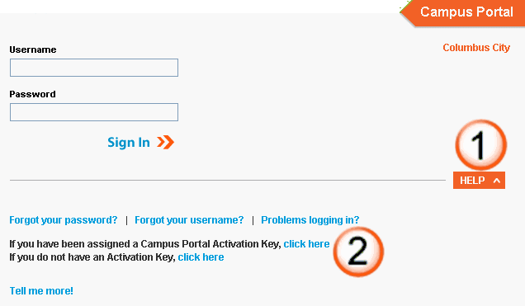
You will then be prompted to create a username and password. Do not enter any spaces in the username. The password must be strong. It is suggested that it contain at least 8 characters, with a mix of upper and lower case letters, a number, and a symbol (such as *, @, or “).

If you have more than one child at the school, you will receive a letter for each child. However, the activation key is the same and only needs to be entered once. For questions or assistance with your login information, please contact the school.

Sincerely,

Principal

